
SUSTANABLE ENERGY ACTION PLAN
of Jelgava City
for the years 2010 – 2020

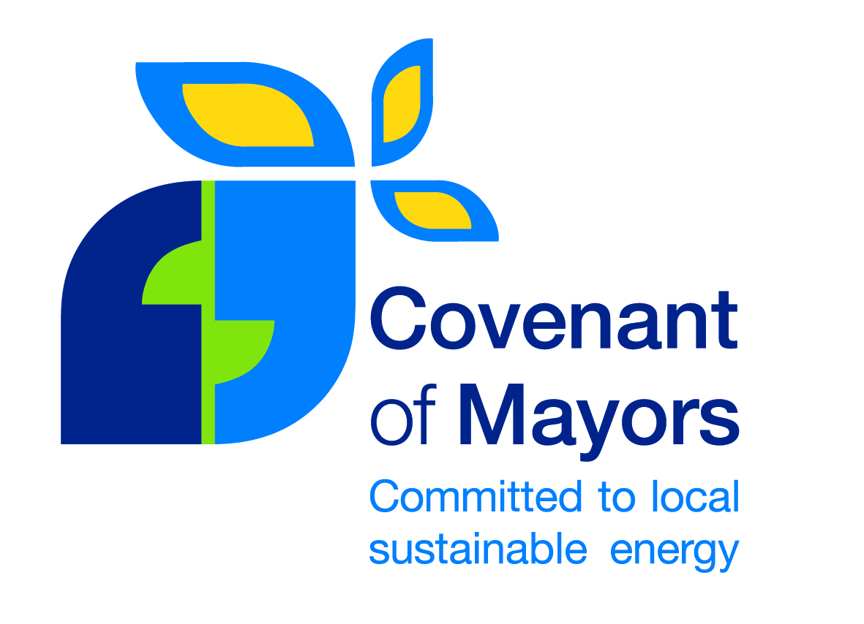
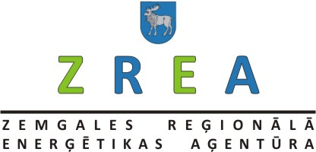
Jelgava 2010

Jelgavas pilsētas
Ilgtspējīgas enerģētikas rīcības plāns
2010. – 2020. gadam

CONTENTS

1. | INTRODUCTION | 3
 | EU main approaches for implementation of sustainable energy policy in the cities | 4
 | Linkage of the Action Plan with the strategic planning documents of Jelgava city | 5
1.3. | Long – term vision of Jelgava city for development of sustainable energy policy | 6
 | Overall CO2 reduction target | 6
2. | CHARACTERISTICS OF JELGAVA CITY | 8
2.1. | Location, business profile and demographical situation | 8
2.2. | Buildings | 10
2.3. | Characteristics of primary resources | 13
2.4. | Heat supply | 18
2.5. | Electricity supply | 21
2.6. | Transport | 25
3. | CONDITIONS FOR CALCULTATION OF EMISSIONS | 27
3.1. | Methodology of calculation of emissions | 27
3.2. | Data for calculations of emissions | 29
3.3. | Calculation results of Jelgava CO2 emissions for time period of 1995-2008 and choice of a baseline year | 30
3.3.1. | Energy production and consumption in Jelgava city in 2005 | 31
3.3.2. | Measures for improvement of energy efficiency | 32
3.3.3. | Heat supply | 35
3.3.4. | Electricity supply | 38
3.3.5. | Transport | 39
4. | MEASURES OF REDUCTION OF ENERGY CONSUMPTION, IMPROVEMENT OF ENERGY EEFICIENCY AND USAGE OF RENEWABLE ENERG FOR 2010 - 2020 | 41
5. | ESTIMATES OF CO₂ EMISSIONS FOR 2010.–2020 AND MEASURES FOR REDUCTION OF THE EMISSIONS | 48
6. | ORGANISATIONAL AND FINANCIAL ASPECTS | 51
6.1. | Management structures for implementation of the Action Plan | 51
6.2. | Financial instruments for implementation of the measures | 51
7. | PROCEDURE OF MONITORING FOR THE REVISION AND IMPLMENTATION OF THE ACTION PLAN | 57
7.1. | Evaluation criteria for the achievement of the goals of the Action Plan | 57
 | Heat supply indicators | 58
7.3. | Procedure of monitoring | 58
8. | INFORMATION SOURCES AND STUDIES USED | 59
 | ANNEXES | 60

- INTRODUCTION

„Sustainable Energy Action Plan of Jelgava City for the years 2010-2020”(Further in the text - SEAP, Action Plan) has been elaborated in accordance with the Covenant of Mayors signed by Jelgava city mayor Andris Ravins and its elaboration corresponds to the conditions of Covenant of Mayors.
The target of SEAP – up to 2020 to reduce CO2 emissions at least per 20%, to increase the energy efficiency per 20% and to produce 20% from the total consumed amount of energy from the renewable energy resources (20/20/20).
Sustainable Energy Action Plan embraces initial overview of CO2 emissions and prognosis, action measures for reduction of energy consumption and development of renewable energy resources in the administrative territory of Jelgava City, as well as the assessment criteria of achievement of the goals of the SEAP. In the Action Plan the main directions of the development of sustainable energy of the city have been determined, which are to be taken into consideration when planning and implementing measures in provision of energy supply, modernization of energy supply systems as well as energy sources, improvement of quality of services and reduction of energy consumption, increase of energy efficiency, in planning and realization of reduction of energy consumption, as well as in inclusion of renewable energy resources in the energy supply system of the city.
Sustainable Energy Action Plan of Jelgava city for the years 2010 – 2020 has been elaborated under the management of Zemgale Regional Energy Agency (ZREA) in close cooperation with the institutions of Jelgava City Council, project partner Kaunas Regional Energy Agency (KREA) as well as energy supply organizations, service companies and experts.

Picture 1 Territory of Jelgava city centre and the Castle

  - EU main approaches for implementation of sustainable energy policy in the cities

The global collaboration for diminishing the climate change was started by the United Nations Framework Convention on Climate Change (in Latvia adopted by law on 23.02.2005.) and with KIOTO protocol of 2005 with liabilities of the countries by 2012.The summit of country leaders in 2009 in Copenhagen discussed the new liabilities for diminishing of the climate change until the year 2050, but the adoption of the new liabilities was postponed to the next years.
The main objective of the liabilities: “Not to allow the raise of average temperature in the world and keep it within limits of 2-2,4 °C up to year 2050.”
Implementing the new energy policy European Union on 9th March 2007 adopted a package of documents ”Energy to the Changing World”, where an initiative was set on Covenant of Mayors of Europe, which was prepared and signed in Brussels in 10th February 2009. At the moment more than 1600 cities have joined the Covenant of Mayors. In the text of Covenant of Mayors the main approaches have been defined as well as tasks to municipalities regarding provision of sustainable energy of the cities, including:

-elaboration of Sustainable Energy Action Plan (SEAP) for the time period up to 2020;
-liabilities to reduce CO2 emissions by 2020 per more than 20%, which is reached by increasing the energy efficiency per 20% and enclosing renewable energy resources in the energy supply per 20% from the total consumption;
-to organize energy days in the city regularly;
- to involve the civil society of the city in the elaboration and implementation of the Action Plan;

Also in the Covenant of Mayors the following conclusions are included:

-conclusion that many actions related to energy demand and renewable energy sources and that have to be done to fight the unfavourable climate change are in the competency field of municipalities or they cannot be realized without the support from the municipality;
-cognition that municipalities, which is the closest structure to the citizens, should be in the front line and should show an example;
-cognition that the responsibility on fight against global warming is shared between municipalities and the governments of the countries and that they in the execution of these tasks should be independent from the liabilities of other persons;

On 3rd March 2010 European Commission has started to put into effect a new strategical direction: “Europa2020” the aim of which is to overcome the consequences of the world recession in Europe and to prepare EU economics for the next decade. 5 objectives have been identified which determine what has to be achieved in EU by 2020 and on the basis of which the achievements will be possible to estimate. One of the objectives states: the objectives 20/20/20 in the field of climate/energy should be achieved.

Elaborating the Sustainable Energy Action Plan the following main EU directives in the field of energy supply, energy efficiency, renewable energy resources and environment have been taken into consideration:

- Directive of the European Parliament and the Council - 2009/91/EC 916.12.2002.) which determines the methodological guidelines for calculation of energy efficiency of the buildings, energy efficiency standards and energy certification system;
- Directive of the European Parliament and the Council 2004/8/EC(11.02.2004.) on promotion of cogenerations based on demand of useful heat in the internal energy market;
- Directive of the European Parliament and the Council 2006/32/EC (5.04.2006) on end-use efficiency of energy and energy services;
- Directive of the European Parliament and the Council 2008/50/EC(21.05.2008) on ambient air quality and cleaner air for Europe;
- Directive of the European Parliament and the Council 2009/28/EC on the promotion of use of energy from renewable energy resources.

  - Linkage of the Action Plan with the Strategic Planning Documents of Jelgava City

Development of Jelgava City is based on the strategical planning documents elaborated by now - Long-Term Development Strategy for Jelgava City for the years 2007-2020 and Integrated Development Programme of Jelgava City for the Years 2007-2013.

Action Plan will be a management tool for Jelgava municipality for achievement of goals set in the strategic planning documents:

Achievement of the strategic goal of Jelgava long-term development strategy: To provide the sustainable development of Jelgava social and economic environment, increase of life quality of Jelgava residents by use of the available resources and to position the city as the development centre of Zemgale Planning Region and EU;
and
For the priority No.3 of city development set for the time period up to 2020: „City with modern and sustainable environment of life” - for implementation of the corresponding tasks:
- To improve environment factor – the quality of air, water, soil;
- To implement measures for reduction of the transit traffic flow within the city;
- To improve and optimize the road safety;
- To establish high quality and accessible infrastructure and services of the public transport;
- To optimize and improve the heat supply system;
- To improve energy efficiency and to promote the awareness of the society of significance of the energy efficiency measures;
- To enlarge and reconstruct the network of engineering communications;
- To develop new and renovate the existing residential fund, including not completed multi residential houses;
- To modernize and develop the infrastructure for education - in establishments of all levels of education;
- To improve and develop the health care infrastructure;
- To improve and develop the social infrastructure.

Implementation of the Action Plan will facilitate the establishment of the sustainable life environment not only in Jelgava city but also in Latvia. It will reduce the use of nature resources by increasing the efficiency of their use and by introducing environmentally friendly technological solutions.

The up to now development of the heating supply sector has been based on Jelgava Development Strategy of Heating Supply System for the years 2005– 2015, which has been elaborated with the objective to ensure planned development of the heat supply system which would guarantee its high energy efficiency, safety, as well as reduction of the harmful emissions and CO2 in the surrounding environment.
The strategy envisages the following development directions:
- Increase of the energy efficiency and safety by introducing new, modern technologies in the heat production;
- Optimization of the district heating system in the right bank of Lielupe River;
- Planned renovation of the previously not reconstructed magisterial and distribution heat supply networks, by changing the heat supply pipes with high heat losses to pipes of pre-fabricated polyurethane insulation;
- Attraction of new heat consumers.

  - Long-Term Vision of Jelgava City for implementation of Sustainable Energy Policy

Vision:
Effective city in terms of resources, with objective to promote economical development by reducing CO2 amount in our economy, by increasing the use of renewable energy resources, by modernizing the transport sector and facilitating the energy efficiency.

1.4. Overall CO₂ reduction target
Jelgava City Council has committed to reduce CO2 emissions until year 2020 at least by 20 % comparing to the baseline year - 2005.

Year 2005 was chosen as the baseline year because in 2005 the production, infrastructure, environment and the society of Jelgava City had stabilized after the recession of the 1990-ties and energy consumption as well as CO2 are to be considered as optimal for the situation of those times.
It was calculated that 107 706 tones of CO2 emissions were emitted in the baseline year - 2005 in the territory of Jelgava city. In order to reach the goal of Covenant of Mayors, the amount of CO2 emissions would have to be reduced per 20%, e.g. - at least per 20 544 tones.

2. CHARACTERISTICS OF JELGAVA CITY
2.1. Location, business profile and demographical situation

Jelgava is located in the central part of Latvia – in the northern part of Zemgale plain, on the banks of the river Lielupe. City characterizes with even relief. Absolute land mark values are from 2,5 to 4,5 meters above the sea level. Therefore, the level of ground-water is high. Territory of the city is 60,3 km2, of which 272 ha are open waters, 1264 ha - forests, 162 ha – parks and squares.

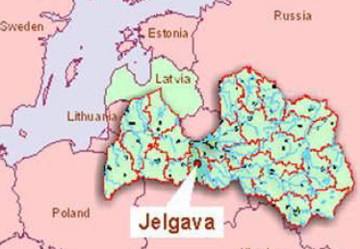
Picture 1 Location of Jelgava

Location of Jelgava and the intersection of transit roads has contributed to the development of it as one of the most significant transit centres. In Jelgava 5 railway lines and 6 magisterial roads intersect: the magisterial road of Europe and State importance (A8-E77) Riga - Jelgava – Lithuania (which is a part of the magisterial road Kaliningrad - Pskov); State 1st level roads Jelgava – Kalnciems (P99), Jelgava – Tukums (P98), Jelgava – Dobele –Annenieki (P97), Jelgava - Tervete-Lithuania (Žagare)(P95), Jelgava – Code (P94); railway lines Tallin - Riga - Vilnius, Berlin - Warshaw - Riga.
The main cargo flow in Jelgava railway terminal are related to with transit traffic in the East-West directions: Moscow - Rezekne - Krustpils - Jelgava – Ventspils, Krustpils - Jelgava – Liepaja.
Jelgava city borders with Ozolnieki County and Jelgava County. It is the biggest town in Zemgale Planning Region and the 4th largest city both in terms of territory and the number of inhabitants.
On 1st January 2010 64898 residents were declared in Jelgava city (in 2008– 65 510, in 2007 – 65 644). The number of inhabitants in Jelgava has decreased in the last years, the overall tendency of decrease is being kept and is also prognosed up to year 2020.
The density of inhabitants in Jelgava is 1 076 residents per km2.

Graph1 Number of residents in Jelgava
Source of information: LR Central Bureau of Statistics

In Jelgava significant business sectors are production of metal products and machine building, production of timber and wood products, publishing and printing, non-metallic mineral products industry the volume of which has tendency to grow, etc. In recent years the revival of metal and machinery sector can be observed, in the city new companies are being opened. The biggest metalworking companies of Jelgava are competitive in the external market, and to maintain this competitiveness part of the metalworking enterprises of the city used the EU Structural Funds for changing the technological equipment and for optimization of the process, which makes it possible to increase productivity and quality of the product
In Jelgava, woodworking and furniture production industries are characterized by the fact that wood-working products with high added value are produced, part of which are being exported.
In Jelgava there is one of the largest universities of Latvia - Latvia University of Agriculture located, which makes Jelgava the largest regional student city in the country. Every year about 7,000 students are studying at the University.

2.2. Buildings
In Jelgava multi-storey residential areas have developed historically, starting from the first post-war years. As Jelgava was completely destroyed during the 2nd World War, the renovation of the buildings was concentrated in the central part, renovation of which lasted to the late eighties. The residential areas built during the Soviet times are very large, impersonal and of utilitarian type, the technology and construction quality is very low. Measures to improve the quality of the living environment have to be implemented almost in all the areas, however, for each area they will be different depending on the year of construction, type of the residential building, level of amenities, etc. factors to be identified in the concrete planning process.
Most of the residential buildings have been built in the time period from 1960 to 1989 (79%). Up to 1948 – 4.63% of the residential fund has been built, from 1948 to 1959 – 11.74% of the total multi residential living fund. After 1989 – 4.63%.

Type of the design | 103 | 316 | 104 | 318 | 602 | 467 | 464 | 114 | Individual design
Number of residential houses | 112  (32%) | 50  (14%) | 44  (12%) | 21  (6%) | 17  (5%) | 14  (4%) | 5  (1%) | 2  (1%) | 88  (25%)
Table 1 Types of designs of multi residential houses in Jelgava city
Source of infrmation: Jelgava house maintenance company, Ltd data (SIA“JNĪP“)

The most common in Jelgava are the buildings of 103 design, the second most common are the buildings of individual designs. From the series-type of buildings the second place is taken by the 316th and 104 type designs, followed by the 318th, 602nd design and 467. There is also a small number of buildings of the 464th 114 design in Jelgava..
In the late forties the first quarter of the city central area was constructed with multi storey residential buildings. The buildings of those times were three to four storey brick masonry buildings with inter-floor coverings made of wood and asbestos sheet roofing. The buildings were located per perimetrical construction principles and were built mainly after individual designs.

In the sixties the construction of series-type multi floor residential buildings was started in Jelgava. During this time mostly the houses of 316 type design were built - five-storey residential buildings with small flats. Such buildings were also constructed in the central part of the city. Inside the blocks of the building so-called free planning principles appeared, when the arrangement of the buildings in the land plot was determined according to the meridional orientation to ensure a sufficient sun light in the apartments.

In the seventies, taking into account that in the central part of the city a free land for building was running out, for residential construction new territories in the periphery part of the city were planned. Construction of residential buildings was carried out according to the principle, which anticipated that a number of major industrial companies and institutions had their own building area, where the residential buildings had to be built as well as utilities, access roads, public utilities at the company’s expense. In each building block in accordance with the detailed plan a community centre, commercial and service institutions, kindergartens and other infrastructure bodies were designed.

Unfortunately, the primary focus was on residential construction not devoting the necessary resources for public buildings. Such a housing policy has led to the situation when in several places of the city there are unfinished residential blocks or groups of buildings, which fragment the building structure of the city, there are unreasonably long lines of utilities leading to those blocks, causing large energy losses. People experience inconveniences having to travel long distances from residential areas to jobs or public institutions in the central part. Mostly for building of those houses a type-designs were used.
Post-war buildings which mostly were built by the standard solutions and since the mid 60thies by use of construction methods of the pre-fabricated panels with a low thermal resistance, which were in line with the standard requirements of construction of those times as priority was low construction costs. These buildings is the key concern for the city, as it is necessary to improve the energy efficiency of the buildings and to reduce the energy consumption, meanwhile achieving the reduction of CO2 emissions. Task is particularly difficult due to fragmented property ownership of apartment buildings
There is also a number of public buildings in Jelgava – culture house, museums, banks, buildings of state and local government, institutions and offices, university, schools, preschool educational establishments, hospitals and commercial complexes, sports and recreation facilities and structures. Of particular note are the schools and nursery schools built in the post-war period after type-designs, the heat resistance of which is low.

There are 493 apartment buildings in Jelgava, which are maintained by Jelgava housing maintenance company (SIA “JNĪP ") (423 or 86%), " Nebruk " Ltd (36 or 7%), cooperatives and joint stock companies (20 or 4%) and “Rimidal V"Ltd (14 or 3 %).

423; 86%
36; 7%
14; 3%
20; 4%
"JNĪP"Ltd
"Nebruk"Ltd
"Rimidal V" Ltd
Cooperatives and joint
stock companies
Graph 2 Housing maintenace companies of multiresidential houses in Jelgava city
Source of information: data of Jelgava city municipality

Jelgava housing maintenance company "JNĪP" and other house maintenance companies are carrying out energy efficiency measures to reduce heat losses in the apartment buildings. Energy efficient renovation of houses is carried out by improving the heat insulation of the external walls of the buildings. "JNĪP" as well as other house maintenance companies carry out changing of the windows with PVC windows in the staircases significantly reducing the heat losses from the shared facilities.
Significant heat loss reduction is provided by the reconstruction of the heating systems of the buildings as well as improvement of the insulation of the internal piping and introduction of heating regulation devices.
Implementation of the above measures will improve the energy efficiency of the district heating, will reduce the energy consumption (fuel, electricity, water) as well as CO2 emissions.
2.3. Characteristics of Primary Resources

In Latvia primary resources are provided by local and renewable resources (wood, peat, straw, hydro resources, wind, biomass, biofuel) and imported energy resources (oil, natural gas, coal, etc.). Currently in Latvia in supply of primary resources three types of energy in about equal shares dominate - petroleum products (mainly gasoline and diesel), natural gas and timber. Latvia like many other European Union countries is dependent on import of the primary resources. However for Latvia this dependence has decreased from 86% (in 1990) to 69% (in 2004) in the last 15 years mainly due to wider use of timber resources.
Demand for energy resources in the world is constantly growing. If we assume the total consumption of primary resources in the world as 100%, then EU consumes 14.6% but Latvia - 0.039% of the total consumption of primary resources in the world.

In 2007 in the world the renewable primary energy resources were used at the amount of 12.59% of all the resources consumed, in EU 27 countries 8.18% and in Latvia 30.26%.
Among EU 27 countries Latvia has the leading role in terms of use of renewable energy for electricity production. In 2005 69.58% of all electricity was produced from renewable sources, in 2006 - 56.96% and in 2007 - 59.27%.
In Latvia the heat amount produced form the renewable energy sources is 15% of the total generated heat, which is the 5th best indicator among the 27 countries of EU after Sweden, Austria, Denmark and Finland.

0
60
120
180
240
300
1990
1994
2000
2004
1990
1994
2000
2004
0%
20%
40%
60%
80%
100%
Coal and other solid fossil fuels
Oil products and shale oil
Natural gas
Wood
Heating energy
Electricity
Households
Transport
Industry
Services
Agriculture
Graph 3 The total consumption of energy resources and the structure of total consumption in % in Latvia
Source of information: Guidelines for Energy Development for 2007 – 2016

Approximately 45% of total primary energy consumption is used for production of heat and electricity. More than 20% of the total primary resources consumption in the transport sector comprises the fuel necessary so it has a significant impact on the structure of primary resources and dependence on import of the resources.

In Latvia heating supply from the primary resources used almost 90% consist of two types of fuel - natural gas and fire wood. The dominant fuel in district heating systems is natural gas (69.9%), also a large proportion (24.2%) is firewood.

Consumers are free to select the type of fuel they want to use if it is not in contrary to the technological, safety and environmental requirements. The current choice of fuel is determined by the availability of the natural gas. Consumers who have accessibility to natural gas supply network mainly use this type of fuel because of the high comfort of use it offers (automation, regulation) and due to the relatively low investment costs in combustion plants.

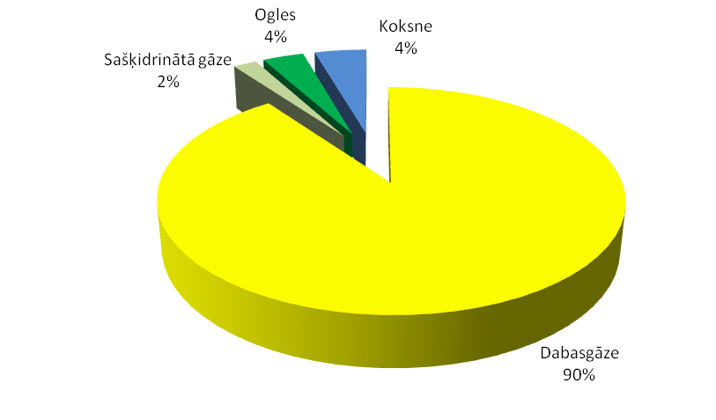
Graph 4 Consumption of the primary resources for heat supply in Jelgava city in 2005
Source of information: Data of Zemgale Regional Energy Agency
yellow | natural gas
light Green | liquid gas
dark green | coal
blue | wood

Currently the main renewable resources, which are widely used are wood and hydro resources, to a lesser extent - wind power, straw and biogas, which also occupies an important place in Latvia primary energy balance.

In Zemgale region a special attention should be given to straw and agriculture biomass products. The potential of them in Zemgale region, Jelgava and Bauska counties is very high. Given that there are large cities in the region which have to provide heat and electricity, the most beneficial are the cogeneration stations, the efficiency level of which is much higher.
Development of capacity of cogenerations plays an important role in the improvement of power supply security as well as in reduction of losses in the electricity transmission. By fostering development of regional CHPs the energy supply is provided for the main objects in the immediate areas of consumption.

In Jelgava in the structure of the primary energy the major part is natural gas, which in a multi-year period comprises 90%.

Graph 5 Structure of Energy Resources in Jelgava city
Source of information: LR Central Bureau of Statistics

Primary energy consumption in Jelgava is fully linked with the consumption of natural gas, natural gas is used for providing heat for heating supply and provision of hot water as well as for generation of electricity. In the recent years a reduction in energy consumption can be observed..

Graph 6 Total consumption of energy resources in Jelgava city
Source of information: LR Central Bureau of Statistics

Dark blue - diesel
Grey -petrol
Light blue - wood
Red -peat
Violet - coal
Green – liquid gas
Yellow – natural gas
Light violet - mazut
Blue – electricity

Graph7 Changes in consumption of energy resources in Jelgava city
Source of information: LR Central Bureau of Statistics

Dark blue - diesel
Grey -petrol
Light blue - wood
Red -peat
Violet - coal
Green – liquid gas
Yellow – natural gas
Light violet - mazut
Blue – electricity

By carrying out correlation, depending on the quantity of degree days, it is obvious that changes in energy consumption over the past five years are very minimal, so this was the base for choosing the year 2005 as a baseline year.

2.4. Heat Supply
Latvia is located in the cold climate zone with days when heating in necessary - heating degree days ≥ 4000. Consequently, the heat supply is necessary not only for provision of the quality of life, but also as a prerequisite for survival during the winter, which lasts about 200 calendar days. Heat supply is a particularly important energy area as more than 60% of the energy spent in the country is used for heating.

The normative degree days of the district heating season of Jelgava comprises 3654 degree days. Under provisions of Latvia Building Norms LBN 003-01 "Construction Climatology” the district heating days for Jelgava are assumed the same as in Riga, where the duration of heating period is 203 days and the average air temperature is 0 ° C

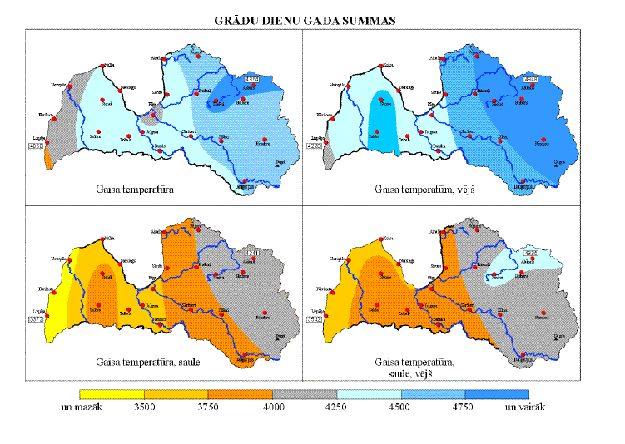
Picture 2 Yearly Amounts of degree days in Latvia
Source of information: Data of Latvia Centre of Environment, Geology and Meteorology

Taking into consideration that in Jelgava city heating season is not started for all the buildings at the same time, for the calculation purposes heating days are assumed as 203 days, while the average air temperature is assumed according to the real temperature in the heating season.

Graph 8 Number of degree days in Jelgava per years
Source of information: Data of Latvia Centre of Environment, Geology and Meteorology

Compared to the normative year the number of degree days decreases every year. In 2008 the number of degree days per year has decreased by 18% compared with the number of degree days in the normative year, wherewith the heat consumption for heating purposes decreases as well.
In Jelgava city the heat supply of residential houses, public buildings and industrial premises is provided by Jelgava city district heating system or local heating sources, which have been constructed to provide heat for a separate house or group of houses. The system is managed and operated by SIA “Fortum”, which within the limits of its license produces, buys, supplies, distributes and sells the heating energy to the consumers.

Jelgava heat supply system consists of two mutually not connected district heating systems, one situated in the left bank of Lielupe river, the other – in the right bank of Lielupe river, and also from 5 small capacity local heat supply systems. The total length of heat supply system is 70,3 km, from which 2,3km is above-ground heating network, 50.0 km is underground network, from which 43.1km are laid without surrounding channels – they are made of prefabricated pipes and 6,9km laid in concrete channels – steel pipes with rock-wool insulation. Besides them 18 km of pipe network is located in the technical corridors of the buildings.
For the consumers in the right bank of Lielupe river the heat production and supply is provided by the gas boiler plant in 47 Aviacijas Street which was handed over for exploitation in 2008, where 3 boilers have been installed with the total capacity of 28 MW. The consumers, which are located far from the system of the right bank of river Lielupe are provided with heating by use of 4 local boiler houses – in Kalnciema cels, Zalu, Skautu and Neretas streets. The amount of heating energy produced by the district heating system of the right bank of Lielupe River is about 25% from the total amount produced for the district heating system. The type of fuel used for heat production is natural gas.
The overall average fuel efficiency in combustion boilers is 93.0%. All the heat sources are equipped with the fuel and heat energy meters. The technical condition of the equipment in the boiler houses is satisfactory.
To most of the consumers the heating system is connected via individual heat points of the buildings. The total number of individual heat points connected to the system is 605, of which 551 are equipped with a new technological equipment operating in automatic mode and regulating the heat supply in the heating system of the building depending on the outdoor temperature and the desired comfort level of the consumers.
In the heat points also the hot water is prepared. The heat meter system allows consumers to pay for the heating in accordance with the total consumption of heat of the building, according to the heat meter readings, which in turn stimulates people to implement energy saving measures in their houses. Heat tariffs for the sale have been approved by the Jelgava Regional Regulator of Public Services.
The total heat production ranges from 215,000 ÷ 225,000 MWh / year, the average amount of heating energy sold to consumers ranges from 178,000 ÷ 186,000 MWh / year. Fluctuations in volume of heating energy depend mainly on the outdoor temperature and the duration of the heating season.
Average heat loss rate is 17.3% of the total heat amount supplied to the network.
From the total amount of heating energy supplied to the customers, 78.2% are supplied to the residents, but 21.8% - to other customers like public buildings, educational and health institutions, as well as trading companies.
From the total amount of heating energy supplied to the customers 75.7% are used for heating purposes, 24.3 % - for preparation of the hot water.

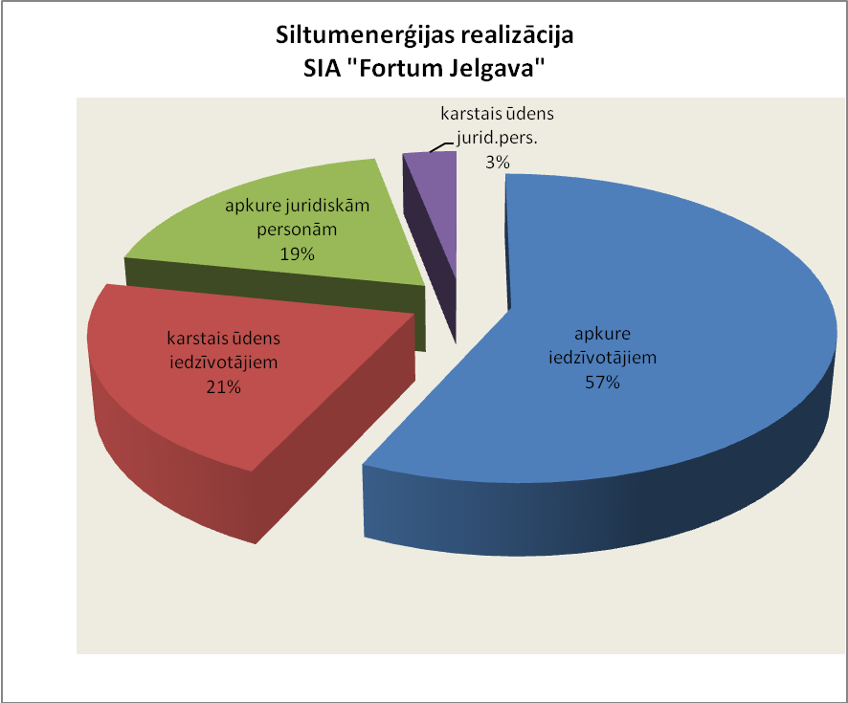
Graph 9 Distribution of the heating energy consumed per types of consumption
Source of information: „Fortum Jelgava”Ltd data
Heating for residents | 57%
Hot water for residents | 21%
Heating for legal entities | 19 %
Hot water for legal entities | 3%

Title | Unit of measurement | Total | Including
Title | Unit of measurement | Total | Multi residential houses | Private houses | State and Municipal institutions | Other consumers
Number of houses connected to the district heating system | building | 585 | 363 | 27 | 43 | 152
Number of clients | client | 15 273 | 14 9635 | 28 | 42 | 268
Area to be heated | m² | 1 186 849 | 831 847 | 2 144 | 162 268 | 190 590
Including the connected areas in 2010 | m² | 10 042 | 3 450 |  | 718 | 5 874
Table2 Number of buildings connected to the district heating system, number of clients and areas to be heated on 1st October 2010.
Source of information: „Fortum Jelgava”Ltd data

2.5. Electricity Supply

Latvenergo AS is the leading producer of electricity and thermal energy in Latvia. The power plants of Latvenergo AS generate more than half of the total amount of electricity consumed in the country. 61 % of electrical energy consumed in Latvia is produced locally, 39 % is imported. Electricity network of Jelgava city is integrated in the overall electricity supply system of Latvia

Graph 10 Production of electricity ( in percents)in 2005 in Latvia
Source of information: Latvenergo data

Graph 11 Production of electricity ( in percents)in 2009 in Latvia
Source of information: Latvenergo data

Electricity supply in the city is ensured by three substations – 330/110/20/10kV substation “Viskaļi” is located in the southern part of the city, 110/20/10kV substation “Miezīte” is located in the northern-western part, whereas 110/20/10 kV substation “RAF” is located in the northern-eastern part of the city. Substation “Viskaļi” is connected to energy supply system by four 330 kV and seven 110 kV electricity supply lines.
Energy is also produced locally in Jelgava. Electricity is being produced in local CHP (that uses natural gas for energy production) – 12 400 MWh of electricity were produced in 2005.

From the above electricity sub-stations electricity is supplied to the urban consumers through the 20 - 0.4kV networks, consisting of air and cable lines. Air lines comprise 366 km (20kV - 101 km, 0.4 kV - 265km). Cable lines - 431 km.
It is planned to connect new urban areas and big customers to the existing 110 kV substations or to construct new substations and to develop 20 - 0.4 kV networks in accordance with the procedure of connection

Public lighting
Street lighting network of Jelgava city is mainly composed of complex, branched structure, having many power centers which can be operated from distance by a magnetic launchers. Part of the lighting network is turned on with help of time setting and photo relays. Such a system can be operated from one control center.
The total length of street lighting network in the city is 227 km, the city lighting is provided by 5200 luminaries, of which 300 are of old – DRL type lamps and 4900 new – sodium lamps. Since 2005 municipal service company JPPA „Pilsetsaimnieciba” provides street lighting in Jelgava city.
To ensure high quality and efficient lighting of Jelgava streets and educational establishments in 2007 a study was carried out “The research and feasibility study for modernization of external lighting systems of Jelgava streets and educational establishments”. On the basis of this study a reconstruction plan of street lighting has been elaborated within framework of which the system is gradually improved - fitted with modern poles with the newest type of energy efficient light bulbs Na.
Each year there is a new construction of street lighting and reconstructions done in the city, still the small investment cannot significantly improve the overall lighting system in the city. Only recently renovated objects can be considered as fully satisfactory lit streets, squares and parks. In the renovated streets pedestrian crossings are well lighted whereas in the other streets pedestrian crossing lights are at critical condition, as luminaries do not work or are too far away from them, so the lighting level at night is near to zero.

In the recent years electricity consumption has increased due to increase of the number of lighting points. However within the framework of the reconstruction both street lighting and its management system is upgraded which in future will let to reduce the electricity consumption by 15-20%.
Graph 12: Consumption of electricity for street lighting in Jelgava city
Source of information: Data from "Pilsētsaimniecība"

Electricity is also used for traffic organization in the streets - currently there are 39 traffic lights operating in the city. During the street reconstruction and improving road safety in recent years the number of traffic lights is increasing in the city, thereby also the power consumption.

Graph 13.grafiks Electricity consumption for traffic lights in Jelgava city
Source of information: Data from "Pilsētsaimniecība"

2.6. Transport
The current traffic organization of the city was created about 25 years ago according to the factories, schools, commercial areas, residential areas and residential housing estates situated in town then and it is outdated. Jelgava city lacks alternative roads for transit transport. Currently the main magisterial line crossing the city Riga - Lielā Street - Dobele is overloaded with transit and freight transport and hinders public transport services. Given the existing demand in certain street segments it would be necessary to increase intensity of the public transport. Since the end stop for the most passengers is in the city center the greatest impact would be on the streets in the city centre. For improvement of the quality of urban environment and for reduction of the air pollution the optimization of traffic flow in the city center would have to be done by directing transit traffic to the belt roads thereby removing some traffic from the city center.
Jelgava Land Use Plan for 2009 to the 2021 envisages the key objectives in the development of the road infrastructure, including:
1) To improve and develop the traffic organization system providing reduction of the traffic congestion and environmental pollution;
2) To create comfortable, safe and attractive (price, service, etc.) public transport network
for the passengers;
3) To develop an advanced, energy-efficient, easy exploitable street lighting network;
4) To improve the organization of traffic through the physical, organizational and telematic means.
There are 368 streets in Jelgava with the total length - 264.43 km. In 2005 in Jelgava there were 28,532 transport vehicles. It was calculated that 27,244 tones of CO2 emissions were emitted in the atmosphere from the variety of vehicles.

30 832
31 936
31 164
28 532
23000
24000
25000
26000
27000
28000
29000
30000
31000
32000
33000
2004
2005
2006
2007
2008
2009
Graph 14 Number of registered transport vehicles in Jelgava city
Source of information: Data of Road Traffic Safety Directorate

The number of registered vehicles in Jelgava in the previous years had a tendency to rise which increased traffic congestions especially in the morning and peak hours. Due to recession in the economy a reduction in number of vehicles can be observed.

In 2005 in Jelgava the total length of public transport routes was 134.36 km, including 75.9 km within borders of Jelgava city, the density of public transport network in 2005 was 1.27 km/km2, and intensity of public transport per 1 km2 was as follows: weekdays - 129.1 km of public transport per day, in weekends 112.6 km of public transport per day. The intensity of the public transport per capita on weekdays was 0.13 km of public transport per day and on weekends - 0.11 km of public transport per day.
SIA „Jelgavas autobusu parks” nodrošina sabiedriskā transporta pakalpojumus Jelgavas pilsētā un rūpējas par videi draudzīgu transportlīdzekļu iegādi. Laika posmā no 2004. gada līdz 2010.gadam veikti sekojoši autobusu parka tehnikas uzlabojumi, lai samazinātu kaitīgāsemisijas:
In Jelgava city and vicinity 71 vehicles of public transport are used, including 10 mini-buses, 15 medium-size buses and 46 buses. Most of the buses are new and environmentally friendly. Currently in accordance with the laws and regulations in force from the total petrol consumption for Jelgava public transport 5% is biofuel.
“Jelgava Bus Park” Ltd (SIA „Jelgavas autobusu parks”) provides public transportation services in Jelgava city and takes care of the purchase of environmentally friendly vehicles. During the period from 2004 to 2010 the following technical improvements of bus fleet have been made to reduce the harmful emissions:

Year 2004: 10 new Ford Transit buses, emission standard EURO 3;
5 new 8700 Volvo buses, emission standard EURO 3.
Year 2005: 12 new Ford Transit buses, emission standard EURO 3;
10 new Mercedes Benz O 530 Citaro buses, emission standard EURO 3.
Year 2006: 12 new Mercedes Benz O 616 Sprinter buses, emission standard EURO 3;
20 used (production year 1996) MAN NL 202 buses, emission standard EURO 2
Year 2008: 1 used (production year 2003)Mercedes Benz O 550 Integro bus, emission
standard EURO 3.
Year 2010: 5 new VDL Berkhof Ambassador 180 buses, emission standard Euro 5.

3. CONDITIONS FOR CALCULATION OF EMISSIONS
3.1.Methodology for Calculation of Emissions

As a basis for calculation of volume of carbon dioxide (CO2) emissions all kinds of energy consumption in all the territory of Jelgava city of all the year, irrespective of the place where this energy is produced. CO2 emissions are calculated separately for electricity consumption, consumption of heat energy in district heating system, consumption of fuel for transport and final energy consumption in households, industry, state and municipal enterprises and in service sector.
From the group of gasses creating greenhouse effect only CO2 emissions are calculated. In calculation of emissions the “standard” methodology and parameters have been used from the guidelines elaborated by IPCC - Intergovernmental Panel on Climate Change. The algorithm used for calculation of CO2 emissions in Jelgava City:

Final energy consumption

Specific emission factors of types of fuel

Calculations of emissions per groups of consumers

Consumption of electricity

Specific emission factor of electricity

Calculations of emissions per groups of consumers

Consumption of heating energy in DH system

Calculated emission factors of production of heating energy

Calculations of emissions per groups of consumers

Consumption of petrol for transport

Specific emission factors for types of petrol

Calculations of emissions per groups of consumers and types of petrol

TOTAL CO2 EMISSIONS IN JELGAVA

Picture 3 Calculation algorithm of CO₂ emissions in Jelgava city

In calculation of CO2 emissions the energy consumptions which cannot be influenced by municipality and which is beyond competency of municipality, are not taken into consideration, such as sea and rail transport, all kind of freight transit, aviation services, use of agricultural and construction technique. Also the emissions from the industry technologies, decomposition processes of natural organic substances, sewage treatment tanks and landfills as well as from open burning processes.
In calculation of CO2 emissions the factors based on average physical properties of fuels used in Latvia are applied as well as methodological instructions of IPCC.

For calculation of CO2 emissions from the electricity consumption the emission factor is used, which characterizes the average structure of production of electricity in Latvia (instructions from SEAP-guidebook) as electricity consumed in Jelgava is provided from different sources of electricity production.

For calculation of CO2 emissions from the consumption of heating energy in the district heating system the emission factor is used, which is calculated basing on structure of production of heating energy and structure of fuel in that particular year. Algorithm for calculation of CO2 emission factor of production of heat energy in the district heating system:

CO_{2VES}
E_{F} =
V_{SA}

Where:
E_{F} = CO2 emission factor in district heating system [t/MWh]
CO2_{VES} = total amount of CO2 in the heating supply produced by the local producers [T]
V_{SA} = total amount in district heating, that has been consumed [MWh]

Algorithm for calculation of CO2 emission factor for production of heat energy in Cogeneration stations of district heating:

(V_{S})
K_{S}
E_{KO} = * CO_{2k}
(V_{S}) (V_{E})
K_{S} K_{E}

Where :
E_{KO} = CO2 emission factor in cogeneration stations for heat energy [t/MWh]
CO2_{K} = CO2 emission factor depending on the type of the fuel used in cogeneration station [T]
V_{S} = total amount of produced heat in the cogeneration stations [MWh]
K_{S} = typical efficiency coefficient in production of heat energy when not using cogeneration (assumed 90%) [MWh]
K_{E} = typical efficiency coefficient in production of electricity when not using cogeneration (assumed 40%) [MWh]
V_{E} = total produced volume of electricity at the cogeneration station [MWh]

Firstly the CO2 emission factor of heat production in cogeneration stations is calculated, after which it is possible to calculate the total CO2 emission factor for heat production in the district heating system.

3.2. Data for calculation of the emissions

Information about the total heat consumption in the district heating system in Jelgava and per different consumer groups was received from the main heat supply operator ”Fortum Jelgava”Ltd (SIA „Fortum Jelgava”). As a basis for electricity consumption were taken data from joint stock company ”Latvenergo”.
To estimate the structure of energy end consumption in Jelgava the information received from the municipality was used (type of buildings and structure of property).

For the calculation of consumption of the primary energy resources the data provided by LR Central Bureau of Statistics were used. In those data an information has been compiled about total amount of gas, timber, coal, mazut, petrol, and diesel used in Jelgava city. LR Central Bureau of Statistics provided data on the consumption of the primary energy resources in boiler houses as well as in cogeneration stations.

By use of primary energy resources the consumed energy for heat supply and transport was calculated, using conversion factors from mass to energy in units (IPCC 2006).Thus the total consumed volume of energy was calculated. Distribution in separate user groups was done basing on the information provided by the municipality on the total structure of property in Jelgava city - volume, type of use and ownership. From this equitation the procentual equitation was drawn which was used in the further calculations.

For estimation of energy end consumption in the household sector the data were used on structure of energy consumption, number of consumers and characteristics of households from the LR Central Bureau of Statistics “Consumption of energy resources in households” ( in years 1996, 2001 and 2005). In these data there is separately shown information on energy consumption structure in Jelgava households. Selection for the survey is made as stratified incidental selection of one or two-level households.

3.3. Calculation Results of Jelgava CO₂ Emissions for Time Period of 1995-2008 and choice of a baseline year
Becoming a member of Covenant of Mayors Jelgava municipality has committed itself to reduce CO2 emissions in its territory by at least 20% by year 2020. To achieve this goal the fixation of the situation in the municipality in the baseline year was done - in 2005. Before the approval of the baseline year the calculations were made – inventory of the total energy consumption in Jelgava city and CO2 emissions for 1995, 2000, 2005, 2008 years. The results obtained have been compiled in the tables (see Annex No. 1).
Analyzing the results the base year was adopted 2005. Justification for this choice is that in 2005 Jelgava manufacturing, infrastructure, environment and society had been stabilized itself after the recession of the 1990-ties.
This is proved also by the total energy consumption in Jelgava city:
- In year 2005 – 545 986 MWh;
- In year 1995 – 654 432 MWh;
- In year 2000 – 382 987 MWh;
- In year 2008 597 319 MWh .
As well as the total CO₂ emissions:
- In year 2005 - 107 706 t CO₂;
- In year 1995 – 172 217 t CO₂;
- In year 2000 – 83 560 t CO₂;
- In year 2008 – 127 801 t CO₂.

Energy consumption and CO2 emissions in 2005 can be considered optimal for the situation of that time with the least impact from the external factors which could be observed in the late 1990-ties in the form of recession in the form rapid growth in 2007 - 2009.
It was estimated that in the base line year (2005.) in total 107,706 tons of CO2 emissions were emitted in the atmosphere in Jelgava municipality. It is 1.58 tons of CO2 per capita per year.

Graph 17: CO₂ emissions in different sectors in 2005
Source of information: ZREA data
3.3.1. Energy Production and Consumption in Jelgava City in 2005

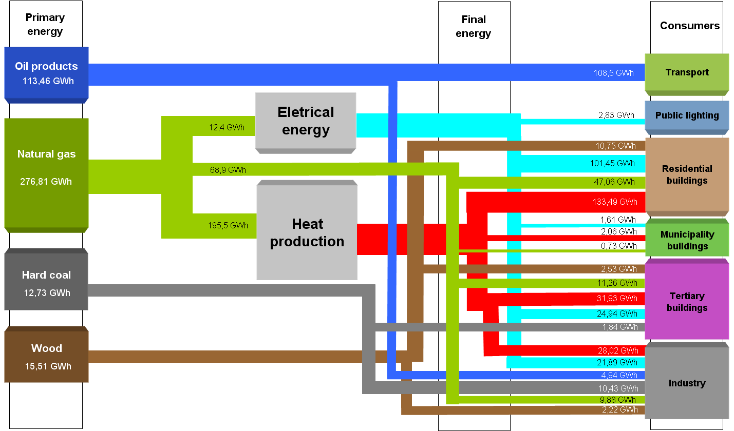

3.3.2. Measures for Improvement of Energy Efficiency
Municipality of Jelgava city already for several years carries out the measures for improvement of energy efficiency:
- Renovations of residential houses
No. | Address of the building | Total costs in LVL | Result/ the works done
1. | 4.līnija 1 | 231 328,72 | Full renovation of the house in 2007
2. | K.Helmaņa Street 3 | 224 064,36 | Full renovation of the house in 2009
3. | Raiņa Street 3 | 130384,- | Energy efficiency measures 2010
4. | Filozofu Street 46 | 225 299,23 | Renovation of the residential building in 2009
Table 3 Renovations of the residential houses up to 2010 including
Source of information: Data of Jelgava City Municipality

- Renovations of the educational establishments
No. | Name of the Project | Total Costs in LVL | Results/ works done
1. | Renovation of the sports hall and the lighting of Jelgava 2nd Gymnasium | 2 823.- | 2000
2. | Renovation of the sports hall and the lighting of Elementary School No.4. | 5 000.- | 2000
3. | Increase of energy efficiency and renovation of 2nd Gymnasium | 234 627.- | 2001
4. | Increase of energy efficiency and renovation of Secondary School No.5 | 136 902.- | 2001
5. | Change of assembly hall windows of Secondary School No.4 | 5 800.- | 2002
6. | Increase of energy efficiency, phase I of Jelgava Elementary School No.3 | 162 600.- | Improvement of heat insulation of the buildings, change of windows and doors,  2007
7. | Increase of energy efficiency, phase I of Jelgava Elementary School No.4 | 212 636.- | Renovation of heating system, improvement of the heat insulation 2007
8. | Increase of energy efficiency, phase I of Jelgava Secondary School No.6 | 123 038.- | Improvement of the heat insulation, finishing of the facade  2007
9. | Energy efficiency project, phase I of Jelgava Sanatorium Boarding School No.1 | 257 414.- | Change of windows and doors, improvement of the heat insulation of the building  2007
10. | Improvement of heat insulation and finishing of the building of Education Department | 95 318,- | Improvement of the heat insulation to the external walls, finishing of the walls , 2008
11. | Energy efficiency measures for pre-school educational establishments | 24 040.- | Change of windows in the kindergartens: „Pasaciņa”, „Vārpiņa”, „Rotaļa”, „Kamolītis”,change of doors in kindergarten„Sprīdītis” 2008
12. | Increase of energy efficiency, phase II Jelgava Elementary School No.3 | 200 000,- | Improvement of the heat insulation change of windows and doors, 2008.
13. | Increase of energy efficiency, phase II, Jelgava Elementary School No.4 | 173 640.- | Reconstruction of the roof, renovation of the heating system, improvement of the heat insulation of the building 2008
14. | Increase of energy efficiency, phase II, Jelgava Secondary School No.6 | 119 580.- | Improvement of the heat insulation of the building, renovation of the heating system 2008
15. | Energy efficiency project of Jelgava Sanatorium Boarding School No.1 | 47 422.- | Change of the roof coverage, change of windows and doors, improvement of the heat insulation of the, 2008
16. | Increase of energy efficiency and reconstruction of Jelgava kindergarten in Pulkv. Brieža Street 23 | 876466.- | Change of windows, change of roof coverage including improvement of heat insulation improvement of the heat insulation to the external walls, finishing of the external walls, reconstruction of the heating system, reconstruction of the electric lighting, 2010
17. | Increase of energy efficiency in educational establishments of Jelgava city municipality | 1 796 064.- | Energy efficiency measures in Elementary School No.3, Elementary School No.2, Secondary School No.4, Jelgava Crafts School, kindergartens in Pulkveža Brieža Street 23A, “Kamolītis , “Pasaciņa” , the total reduction of heat consumption - per 43%, 2010.
18. | Improvement of the infrastructure of Jelgava specialized educational establishments | 295 176.- | Improvement of infrastructure and energy efficiency in Specialized Boarding School No.1,  in Jelgava Specialized Boarding School, in  Jelgava Specialized Elementary School, 2010.
Table 4 Renovation of the municipal education establishments up to 2010, including
Source of information: Data of Jelgava city municipality

- Improvement and promotion of energy efficiency in municipal buildings
Nr. | Title of the Project | Total Costs, LVL | Result/ the Works Done
1. | Increase of energy efficiency in Jelgava History and Art Museum named after Ģ.Eliass | 233 875,22 | 92 windows changed, internal heating system reconstructed, improved energy efficiency  2006
2. | Improvement of energy efficiency in Jelgava public | 232 070.- | Improvement of heat insulation, change of the windows for the buildings in Pasta Street 44 and Stacijas Street 13, 2007
3. | Improvement of energy efficiency in culture house “Rota” | 21 900.- | Change of the windows, 2007
4. | Improvement of the heat insulation of the administrative building of Jelgava municipal police | 10 000.- | Technical Design elaborated,  2007
5. | Improvement of the heat insulation of the facade of the building of ambulance services | 40 840.- | Change of the roof coverage of the building , improvement of the heat insulation to the façade,  2007
6. | Establishment of Zemgale Regional Energy Agency for supporting the energy management and efficiency in the municipalities of Zemgale Region | 480 983.- EUR | Improvement of the energy efficiency and promotion of the renewable energy resources in both public and private sector, 2008
7. | Improvement of the heat insulation of the walls of the hospital | 220000.- | Improved heat insulation of the walls -6390 m2, 2008.
Table 5 Improvement of the energy efficiency of the municipal buildings up to year 2010, including
Source of information: Data of Jelgava City Municipality

3.3.3. Heat Supply
In the previous years significant measures have been undertaken in the renovation and improvement of the energy efficiency of the district heating system:

- From 1994 till 2010 renovation of the existing DH network was made by replacing existing pipes with pipes of pre-fabricated insulation by use of no-canal methods – 80% of the total length of the district heating network have been renovated. As the result of the renovation and optimization of the heating network – heat losses decreased from about 25% in 2001 to 17.4% in 2009. CO2 emissions have reduced per more than 2 448 tones during this period.
- In 2008 optimization of the right bank DH network was carried out – a new gas boiler plant with the total capacity of 28 MW in Aviacijas Street 47 was commissioned as well as DH network was optimized. Consequently it has been possible to significantly reduce the heat losses in the transmission. Actual heat losses in 2009 was 37 327.72 megawatt hours which is 10 109.82 megawatt hours less than in 2008, thus the decrease in fuel consumption for production of this amount of heat energy and thus the CO2 pollution in this period has decreased by 2 250 tones.
- In June 2009 a new gas cogeneration plant with four gas engines each having electrical capacity of 0.999 MW and heat capacity of 1.167 MW in Ganību Street 71A was set into operation. For heat production in the cogeneration process the fuel consumption is about 30% less than if the same amount of heat and power would have to be produced separately. CO2 reduction is 8,221 tons / year.

The above mentioned activities have improved energy efficiency of the district heating system and have given the possibility to stabilize the heat tariffs despite the rapid price increase of natural gas.
The total produced heat 2005 was 185 000 MWh, but the average quantity sold to the consumers was 195,500 MWh / year. Heat losses in the baseline (2005) year accounted for 23.6% of the total heating energy, which was delivered to the system.
Heat consumption (in the district heating system) in Jelgava municipality in 2005 was:
- Residential buildings – 133 490 MWh/year
- Public/state buildings – 31 929 MWh/year
- Municipal buildings – 2 063 MWh/year
- Industry – 28 018 MWh/year
Total – 195 500 MWh/year

Graph 15: Heat consumption in % (in district heating system) in Jelgava city in year 2005
Source of information: „Fortum Jelgava”Ltd data

In addition to the progress made in the previous years, „Fortum Jelgava”Ltd is looking for new opportunities and solutions to improve safety and efficiency of the DH system and to become more competitive in the energy market. The following key activities are planned for the forthcoming years:

- To implement new and modern technologies in energy production by constructing a new biofuel cogeneration plant in Rūpniecības Street 73 that will use alternative fuel to gas – biofuel (wood chips, wood waste). It will increase the amount of heat energy and electricity produced in cogeneration process as well as will reduce dependence of external fuel (natural gas) suppliers with high price of the fuel and unpredictable price fluctuations. The planned capacity for the new plant is 23 MW electricity and 45 MW heat.
- To connect the right and the left bank DH systems, which will let the new biofuel CHP to provide the heat energy also to the consumers of the right bank. The length of the connection line to be constructed is around 1.5 km, diameter of the pipe - DN 400 mm. It is planned to cross river Lielupe by making a horizontal drill technology under the river.
- To proceed with the renovation and optimization of DH network thus reducing heat loses in the network.

As a result of the above mentioned activities, energy efficiency of the DH system will increase, consumption of energy resources (fuel, electricity, water) as well as amount of harmful emissions and green-house gases (CO2) will decrease.

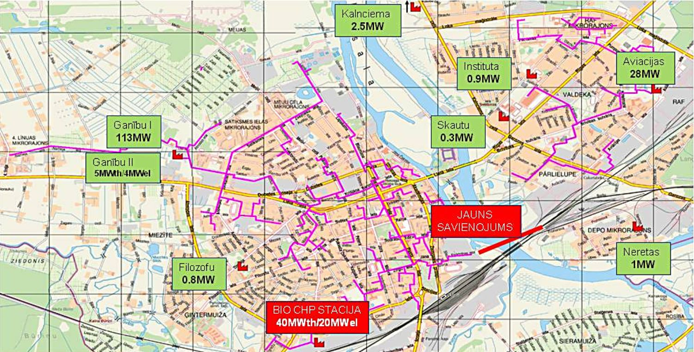
Picture 4: The scheme of the planned heating supply system in Jelgava city
Source of information: data of ”Fortum Jelgava”Ltd

Year | Produced energy in MWh | Heat losses in the network  % | Type of energy | CO₂ tones
2014 | 229 844.3 | 16.1 | Heating energy | 21 133 | *** | PLAN
2014 | 128 113.1 | 16.1 | Electricity | 21 133 | *** | PLAN
2014 | 357 957.4 | 16.1 | Total | 21 133 | *** | PLAN
2010 | 236 488.0 | 16.2 | Heating energy | 59 093 |  | PLAN
2010 | 30 013.1 | 16.2 | Electricity | 59 093 |  | PLAN
2010 | 266 501.2 | 16.2 | Total | 59 093 |  | PLAN
2009 | 215 089.5 | 17.4 | Heating energy | 51 264 | ** | IN FACT
2009 | 17 558.7 | 17.4 | Electricity | 51 264 | ** | IN FACT
2009 | 232 648.2 | 17.4 | Total | 51 264 | ** | IN FACT
2008 | 183 032.5 | 21.2 |  | 39 966 | * | IN FACT
2007 | 180 141.0 | 22.0 |  | 39 626 |  | IN FACT
2006 | 183 735.4 | 18.9 |  | 40 725 |  | IN FACT
2005 | 185 443.1 | 23.6 |  | 41 102 |  | IN FACT
* On 1st October 2008 the thermo-electro power station of Sugar refinery is closed and production of heat energy is started in the new boiler house Aviacijas Street 47
** On 1st July 2009 the cogeneration station in Ganību Street 71A starts its operation.
***The connection line between the district heating systems of both banks is built and Jelgava city is supplied with heat energy from the biomass cogeneration station in Rūpniecības Street 71
Table 6 CO₂ emissions from the combustion stations of ”Fortum Jelgava Ltd
Source of information: Data of ”Fortum Jelgava”

The main fuel used in Jelgava municipality was natural gas (195.5 GWh / year). Thus in the baseline year 39,491 tones of CO2 were emitted (only by the district heating system alone). The houses not connected to the district heating system used natural gas, coal and wood for heating. From the industry in 2005 6575 tons of CO2 were emitted into the atmosphere generated by use of natural gas, liquid gas and coal.

3.3.4. Electricity Supply
Latvenergo AS – the leading producer of electricity and thermal energy in Latvia supplies electricity to Jelgava city. 152 720 MWh of electrical energy was consumed in Jelgava city in baseline year (2005). Therefore 16 646 tones of CO2 emissions were emitted into the atmosphere. Electricity is also produced in local CHPs. 12 400 MWh of electrical energy were produced in Jelgava in the baseline year.

Consumers of electrical energy in Jelgava municipality in year 2005:
- Municipal buildings – 1611 MWh/year
- Tertiary buildings (Non-municipal buildings) – 24 943 MWh/year
- Residential buildings – 101 446 MWh/year
- Public lighting – 2833 MWh/year (street lighting + electricity for traffic lights)
- Industry – 21 887 MWh/year
Total – 152 720 MWh/year

Consumption of electrical energy per capita – 2,31 MWh/year.

Graph16 Consumers of electricity in Jelgava city in 2005
Source of information: data of Latvenergo

3.3.5. Transport
More than a fourth part of CO₂ emissions in Jelgava municipality was emitted by the transport sector. It was calculated that 27 244 tonnes of CO₂ emissions were emitted by different vehicles. The most part of CO₂ emissions was created by private vehicles – 22 455 tonnes. The public transport, accordingly, – 4790 tonnes. Jelgava has a potential to become a centre of logistics in the European level, therefore the municipality is focusing on improvement of the traffic organisation, optimisation of transport flows as well as improvement of the street lighting. The measures taken up till now are already bringing considerable contribution in reduction of CO₂ emissions.

No | Project title | Total costs, LVL | Results/Works completed
1. | Reconstruction of Rīgas from Loka maģistrāle till the administrative brder of the city | 2 761 249.- | 1,8 km reconstructed, incl. cyclists’ roads, pavements, street lighting, velo celiņi, ietves, ielas, road, 2007- 2008
2. | Modernisation of crossing of Uzvaras and Kr. Barona streets | 8 128.- | modernisation of street crossings, traffic lights, video monitoring, traffich flow intensity recording, coordination, 2007
3. | Modernisation of crossing of Meiju ceļš and Satiksmes street | 35 267.- | modernisation of street crossings, traffic lights, video monitoring, traffich flow intensity recording, coordination, 2007
4. | Modernisation of crossing of Lielā street and J.Čakstes boulevard | 4 109.- | modernisation of street crossings, traffic lights, video monitoring, traffich flow intensity recording, coordination, 2007
5. | Creation of infrastructure of Zemgale Technology park | 308 218.- | ielas 0.54 km of Peldu street covered with bituminous concrete layer and set up of street lighting, 2007
6. | Creation of infrastructure of the city Stadium Renovation of Brīvības boulevard from Rīgas street up to Helmaņa street | 2 935 360.- | building of streets, pavements, parking lots, rain drainage network,power lines, traffic lights,  2008
7. | Creation of management system of public transport route network | 50 000.- | izveidots pilsētas sabiedriskā transporta maršrutu tīkls atbilstoši attīstības prasībām (digitālā veidā uz pilsētas kartes), 2007./ 2008.
8. | Building of transport infrastructure and utilities to ensure development of education, health care and entrepreneurship | 3 075 000.- | pavements created, cyclists’ roads, lihting as well as utilities reconstructed  2009
9. | Improvement of transport infrastructure to facilitate the connection from the city centre with surrounding territories | 5 050 000.- | reconstruction of the section of Lielā street from Dambja street up to Māras street and reconstruction of Dobeles road from Māras street up to Atmodas street,  2009/2010
10. | Improvement of traffic security in the section of Rūpniecības – Atmodas street, Jelgava | 386 099,00 | to improve traffic security in the crossings of Rūpniecības and Filozofu streets, as well as Atmodas and Dambja strets, 2009-2011
11. | Reconstruction of Dobeles road from Atmodas street up to 5th līnija | 6 940 351.- | 3.4 km reconstructed, incl. cyclists’ roads, pavements, street lighting, road, 2010 Start up of the project implementation
Table 7: Measures for improvement of traffic organisation and street lighting, till 2010 (incl.)
Source: Data provided by Jelgava municipality
4 . MEASURES OF REDUCTION OF ENERGY CONSUMPTION AND IMPROVEMENT OF ENERGY EFFICIENCY AND USAGE OF RENEWABLE ENERGY FOR 2010-2020

Main tasks for reduction of energy consumption, improvement of energy efficiency and usage of renewable energy (RE) for the period of 2010-2020:

- Improvement of energy efficiency of residential buildings:
No. | Title of the measure | Expected result | Responsible for implementation | Term for implementation
1. | Technical status inspection, energy aidit report of multiresidential buildings under project “Energy effective and coordinated action in the urban deevelopment” | Technical status inspection and energy audit reports for 76 buildings | Jelgava City Council | 2010
2. | Elaboration of Concept for energy efficiency improvement of multiresidential buildings | Concept developed and approved | Jelgava City Council | 2011
3. | Renovation and energy efficiency improvement of multiresidential buildings | Buildings renovated | Jelgava City Council, Jelgava Municipal House-Management Company (“JNĪP”) | 2011-2020
4. | Training and informative materiāls for ensuring of recommendations and training services with an aim to promote energy management, usage of renewable energy resources and ecological building | Prepared and distributed | ZREA | 2011-2015
5. | Preparation of informative materiāls on energy efficiency in public buildings | Materails prepared | ZREA | 2011-2015
6. | Informative events addressed to community residents on issues of heat insulation of buildings | Discussion on implementation of energy efficiency measures | ZREA, JNĪP | According to the ZREA’s Communication plan
7. | Zemgale Energy days in Jelgava | International conference – pesentations, group works, discussions on energy efficiency issues | ZREA | According to the ZREA’s Communication plan
Table 8: Measures for improvement of energy efficiency of residential buildings
Source: Data provided by Jelgava municipality
- Improvement of energy efficiency of educational establishment buildings and municipal buildings:
No. | Title of the measure | Expected result | Responsible for implementation | Term for implementation
1. | Raising of energy efficiency level of Jelgava Secondary School No. 6 | Heat insulation and decoration of the external walls completed | Board of Education | 2013-2015
2. | Renovation of the facade of the State High School | Project design, osmosis of the foundation and the plinth floor of the building, heat insulation and decoration of the building | Board of Education | 2012
3. | Raising of energy efficiency level of the building belonging to youth and children’s centre "JUNDA" in Skolas street 2 | Replacing of roof cover and heat insulation of the roof, renovation of water supply and sewage systems, replacement of lighting | Board of Education | 2013
4. | Raising of energy efficiency level of the building belonging to youth and children’s centre "JUNDA" in Pasta street 32 | Drainage of the foundation, heat insulation and decoration of the facade, renovation of lighting | Board of Education | 2013
5. | On annual base to continue projects related to raising of energy efficiency level of the building belonging to educational establishments | Energy efficiency level of the building belonging to the educational establishments raised, heat consumption economy and reduction of CO₂ emissions achieved | Izglītības pārvalde,  Jelgavas pilsētas dome | 2020
6. | Complex solutions for reduction of greenhouse gas emissions in buildings owned by municipal authorities | Energy efficiency level of the building belonging to the local authorities raised, heat consumption economy and reduction of CO₂ emissions achieved | Jelgava City Council | 2012
7. | Measures to improve heat sustainability of the sociali residential house | Energy efficiency measures completed, heat consumption economy achieved | Jelgava City Council | 2012
Ttable 9: Measures for improvement of energy efficiency of educational establishment buildings and municipal buildings
Source: Data provided by Jelgava municipality

- Reduction of heat losses in the district heating (DH) system and improvement of the heat supply security
The following developments are envisaged in order to reducē heat losses and improvement of the heat supply security for the period till 2020:
- improvement of the heat supply security by introducing alternative fuels;
- improvement of energy efficiency in the heat production enlarging the heat ammount produced in co-generation by using new technologies;
- a planned renovation of unrehabilitaded mains and pipeline network by replacing its parts with large heat losses with preinsulated pipelines;
- integration of autonomous boiler houses into the common DH system;
- ensuring of competitive and predictable sales prices for heat energy;
- increase in ammounts of heat production and supply;
- ensuring of a high quality and competitive service till the pipe entry in the customer’s building by registering the consumed heat in MWH by heat meteors;
- delegation of the calculation of heat energy per square meter and preparation the heat and hot water bills in the sphere of responsibility of the house-managers;
- in cooperation with Jelgava municipality and residential project developpers to develop new DH areas and construction of new infrastructure for the territories of prospective building works of the new residential houses.

No. | Title of the measure | Expected result | Responsible for implementation | Term for implementation
1. | Building of cogeneration power station (using biological fuels) in Rūpniecības street 73 | Energy efficency of the DH system, heat supply security improved | “Fortum Jelgava” Ltd. | 2013
2. | Building of the linkage of the 2 DH systems located in the right and left banks of the river Lielupe | Energy efficency of the DH system, heat supply security improved | “Fortum Jelgava” Ltd. | 2010-2013
3. | Integration of autonomous boiler plants in the DH system | Energy efficency of the DH system, heat supply security improved | “Fortum Jelgava” Ltd. | 2010-2020
4. | A planned renovation of nonrehabilitated heat supply network (15.1 km) | Energy efficency of the DH system, heat supply security improved | SIA „Fortum Jelgava” ” | 2010-2020
5. | Creation o fmanagement systemfor a joint DH operation | Energy efficency of the DH system, heat supply security improved | “Fortum Jelgava” Ltd. | 2010-2013
6. | Creation of an automated reading system of showings by heat consumption meters | Energy efficency of the DH system, heat supply security improved | “Fortum Jelgava” Ltd. | 2010-2013
7. | Measures to attract new clients for joining the DH system | Energy efficiency of the DH system, heat supply security improved | “Fortum Jelgava” Ltd. | 2010-2020

Table 10: Measures for reduction of heat losses in the district heating (DH) system and improvement of the heat supply security
Source: data provided by “Fortum Jelgava” Ltd.

- Usage of alternative resources in power supply
Following the implementation of the project “Fortum Jelgava” Ltd. has developed its heat and power production programme based on the asumption that the new bio fuel CHP plant in Rūpniecības street 73 (with capacity of 45 MW) and the existing gas CHP plant in Ganību street 71A (with capacity of 4.668 MW) will be operated within the base load regime around 8000 hour per year and will supply heat to customers located in both sides of the river Lielupe. Estimated ammounts of heat and power production and their breakdown according to the sources of energy production are summed up the following table:

Title | Total  MWh, | including , MWh
Title | Total  MWh, | CHP plant in Rūpniecības street 73 | CHP plant in Ganību street 71A | Boiler house in Ganību street 71 | Boiler house in Aviācijas street 47 | 4 local boiler houses
Heat energy produced | 240 000 | 168 000 | 39 000 | 14 000 | 14 700 | 4 300
t.p. % of total amount | 100.0 | 70.00 | 16.25 | 5.83 | 6.12 | 1.80
Power produced | 131 200 | 98 200 | 33 000
t.p. % of total amount | 100 % | 74.85 | 25.15
Table 11: Estimated ammounts of heat and power production
Source: data provided by “Fortum Jelgava” Ltd.

- Modernisation of municipal lighting system
Based on the findings of the study carried out in 2007 “Study of Jelgava municipal street lighting and the lighting of educational establishments and preparation of feasibility study ” the municipal Agency “Pilsētsaimniecība”, based on the plan of reconstruction of the lighting system, will continue its work for improvement and development of public lighting system. The project for improvement of the lighting system consists of two parts:
- provision of the street lighting with technological solutions;
- provision of the lighting of educational establishments with technological solutions.
The measures for improvement are envisaged in all the street reconstruction projects s well as the Investment plan of the City of Jelgava, being a part of Jelgava City Integrated Development Programme for 2007-2013.

No. | Title of the measure | Expected result | Responsible for implementation | Term for implementation
1. | Modernisation of the management system for street ligting | Effective and energy efficient management system created | Jelgava Municipal Agency “Pilsētsaimniecība” | 2013
2. | Reconstruction of street ligting | Economic street lighting ensured meeting necessary requirements | Jelgava Municipal Agency “Pilsētsaimniecība” | 2020
3. | Creation of new lighting systems for 23 educational establishments | 262 light points installed in the territories of educational establishments | JPPA „Pilsētsaimniecība” | 2020
4. | Creation of new lighting systems for 2 parks (Valdeka park, Square of the Culture Centre) | 73 light points installed | Jelgava Municipal Agency “Pilsētsaimniecība” | 2020
Table 12: Measures for improvement and development of public lighting system
Source: Data provided by Jelgava municipality

6)Promotion of usage of RES for purposes of provision of heat and hot water

“Fortum Jelgava”Ltd has a plan to build a bio fuel CHP plant in Jelgava by the heating season of 2012/2013. The main benefit from this CHP plant will be the usage of the green primary energy in the heat production. The usage of natural gas will be replaced by a RES – woodhip, the usage of which is a CO₂ neutral process thus contributing to reduction of the climate change essentially mitigating the CO₂ emmission in the municipality of Jelgava.

No. | Title of the measure | Expected result | Responsible for implementation | Term for implementation
1. | Building of cogeneration power station (using biological fuels) in Rūpniecības street 73 | Energy efficency of the DH system, heat supply security improved | “Fortum Jelgava” Ltd. | first quarter of 2013
2. | Informative events to community residents on usage of renewable energy resources | Meeting on usage of renewable energy resources | ZREA | According to the ZREA’s Communication plan
3. | Preparation and dissemination of informative materials on usage of renewable energy resources on energy supply to residential buildings | Imformative booklet | ZREA | According to the ZREA’s Communication plan
Table 13: Measures planned for promotion of usage of RES
Source: Data provided by “Fortum Jelgava” Ltd. and ZREA

7) Development of the municipal public transport

In order to reduce CO₂ emissions created by motor vehicles the main directions of development of the municipal public transport is updating of the vehicle fleet including new environmentally friendly vehicles and, based on the findings of the study in 2006 “Sabiedriskā transporta maršrutu shēmas izstrāde” (“Elaboration of route chart for public transport”), elaboration of new route chart for public transport. The key guidelines of public transport route network of Jelgava and its vicinity are as follow:
- To establish a joint transfer point (the new buss station near the railway station);
- To cut unnecessary long routes shorter by creating new routes linking the cuty centre with subcentres;
- To ensure the transportation of passemgers from the subcentres to the most essential points in the city centrē (schools, kindergartens, public authorities, places of jobs);
- To consider impact of the new route network on the traffic in the city of Jelgava.

No. | Title of the measure | Expected result | Responsible for implementation | Term for implementation
1. | Building of the infrastructure for Traffic terminal (Bus station) | Thanks to the location of the new Bus station it will be possible to divert the distant route public transport in transit from the centre of the city (sing the bypass – Lietuvas road – Stacijas street);  transport flow will be reduced in the city centre | Jelgava City Council | 2020
2. | Procurement of low floor busses of large passenger capacity (emission quota EURO 5) | 30 (10 buses in 2011, 10 buses in 2013, 10 buses – in 2015) | “Jelgavas autobusu parks” Ltd. (Jelgava Bus Park) | 2015
3. | Consomption of biofules by vehicles of Jelgava municipal public transport in % of the total fuel consumption | 5%  8%  10% | “Jelgavas autobusu parks” Ltd. (Jelgava Bus Park) | 2010  2015  2020
Table 14: Measures for development of the municipal public transport
Source: Source: Data provided by Jelgava municipality

5. ESTIMATES OF CO₂ EMISSIONS FOR 2010–2020 AND MEASURES FOR REDUCTION OF THE EMISSIONS

The main goal for all cities of “Covenant of Mayors” to reach 20 % is reduction of CO₂ emissions till year 2020 comparing with the baseline year. By 2020 Jelgava municipality should reduce CO₂ emissions by 25 749 tonnes.
The base used for the CO₂ emission reduction by 2020 are the estimates of the demand in electric power and fuel as well as evaluation of impact for emission reduction measures.
Evaluation of impact for emission reduction measures is carried out taking into account the factors of the saved energy or the ammount of the fuel and emissions for each respective kind of energy or fuel.
The following table comprises the main measures in reduction of emissions in the period following the year of 2005 until 2020 as well as the evaluated potential for reduction of emissions:

No. | Title of the targeted activity | Estimated emmission saving, CO₂ t/year
No. | Title of the targeted activity | 2005 | 2015 | 2020
 | Final consumers of energy
1. | Promotion of usage of RES for purposes of provision of heating and hot water | 51060 | 43401 | 40848
2. | Improvement of energy efficiency of educational establishment buildings and municipal buildings | 787 | 669 | 551
3. | Modernisation of municipal lighting system | 309 | 303 | 294
4. | Development of the municipal public transport | 4790 | 4551 | 4311
 | Production of energy
5. | Reduction of heat losses in the district heating (DH) system and improvement of the heat supply security | 45689 | 34267 | 31982
6. | Usage of alternative energy resources (RES) in power supply | 15320 | 15014 | 14554
7. | Promotion of usage of RES for purposes of provision of heating and hot water | 19247 | 18285 | 17707
Table 15: Estimated ammounts of emissions

As it is showed in the result summary of the table above the largest effect on reduction of emission could be received from the energy efficiency measures in residential and municipal buildings. Other effective results could be expected from measures in the reduction of heat losses in the DH system as well as usage of biomass in the production of heat energy and electric power.

No. | Title of the targeted activity | Estimated emmission saving %  versus 2005, , CO₂ t/year
No. | Title of the targeted activity | 2015 | 2020
 | Final consumers of energy
1. | Promotion of usage of RES for purposes of provision of heating and hot water | 7 659 | 10 212
2. | Improvement of energy efficiency of educational establishment buildings and municipal buildings | 118 | 236
3. | Modernisation of municipal lighting system | 6 | 15
4. | Development of the municipal public transport | 240 | 479
 | Production of energy
5. | Reduction of heat losses in the district heating (DH) system and improvement of the heat supply security | 11 422 | 13 707
6 | Usage of alternative energy resources in power supply | 306 | 766
7. | Promotion of usage of RES for purposes of provision of heating and hot water | 962 | 1 540
Table 16: Estimated emission saving CO₂ t/year

The estimated saving of CO₂ t per year in the first five years, i.e. 2010–2015, is 20 713 t/year, but in the comming five years, i.e. 2015– 2020, accordingly, 26 955 t/year. Therefore saving in ammount of 20% of CO₂ t/year is ensured.

No. | Title of the targeted activity | Estimated emmission saving %  versus 2005
No. | Title of the targeted activity | 2015 | 2020
 | Final consumers of energy
1. | Improvement of energy efficiency of residential buildings | 15% | 20%
2. | Improvement of energy efficiency of educational establishment buildings and municipal buildings | 15% | 30%
3. | Modernisation of municipal lighting system | 2% | 5%
4. | Development of the municipal public transport | 5% | 10%
 | Production of energy
5. | Reduction of heat losses in the district heating (DH) system and improvement of the heat supply security | 25% | 30%
6. | Usage of alternative energy resources in power supply | 2% | 5%
7. | Promotion of usage of RES for purposes of provision of heating and hot water | 5% | 8%
Table 17: Estimated emission saving %

In order to meat the planned indicators there will be a awareness rasing work carried out in the community, Zemgale Regional Energy Agency being already in a leading position in this respect. During the course of the implementation of the plan the monitoring will be an essential factor to reflect the actual situation and will serve as the base for making necessary corrections in the planning as well as performance of the planned work. The municipality would grant favourable grounds for the entrepreneurs, owners of immovables/real estates and rezidents for improvement of the energy efficiency of buildings.

6. ORGANISATIONAL AND FINANCIAL ASPECTS
  - Management structures for implementation of the Action Plan

In order to promote energy efficiency and use of renewable energy resources (RES) in public and private sector as well as to ensure information availability to society on these issues in 2008 with the support by the innitiative of the European Commission “Intelligent Energy – Europe” the society “Zemgale Regional Energy Agency” (ZREA) was established. ZREA is providing advice, informative and training services in the energy sector, is searching investment to attract it for the projects promoting energy efficienty, facilitates cooperation in the area of energy among legal and physical persons in local, national and international level as well as maintains its newly created energy database.
In order to achieve goals of the Covenant of Mayors and ensure the implementation of the Action plan cooperation is needed by speciālists of the municipal institutions, administration and stakeholders (local producers of energy, local transport companies, public organisations etc.). The main role in organisation of implementation of the Action plan belongs to Zemgale Regional Energy Agency which in accordance with the obligation by the Covenant of Mayors would prepare and submit Progress report on the implementation of the Action plan to the City Council of Jelgava and the Office of the Covenant of Mayors at least in every two years.

  - Financial instruments for implementation of the measures
EU Structural and Cohesion funds
The existing Structural and Cohesion funds are established for the perid 2007-2013 and its aim is to support integration of different regions and infrastructure, esspecially regarding transport infrastructure, inter alia:
European Social Fund (ESF) concentrates on promotion of the competetivenes of the rezidents and their adaption to the requirements of labour market, erradication of any kind of discrimination, cooperation in the area of reforms etc.
European Regional Development Fund (ERDF) supports the balancing of regional development wihin the EU, promotes the public and private partnership. This fund supports the traditional networking in the energy setor, measures of environment protection, energy effiviency and usage of renewable energy resources.
Cohesion Fund (CF) supports addressing of environment issues and creation of transport networks in Europe, including railway, river and sea as well as air transport. The fund is supporting measures that are defined as mitigating the change in nature, including the improvement of energy efficiency and usage of renewable energy resources.
The EU programme“Intelligent Energy – Europe”, which is managed by The Executive Agency for Competitiveness and Innovation (EACI), it developes and supports stumdies, Exchange of experience and information on the issue of innovation. The EU programmē “Intelligent Energy – Europe” supports the creation of local/regional energy agencies by organising annual calls for submission of proposals and co-financing their operation during first 3 years in ammount of 50-75% the necessary budget.

Green investment schemes
Green Investment schemes (GIS) is a global international measure focused on elimination of greenhouse gas emissions compensating the dicharge of these gases in one place with a emission reducing activity in another. The funds acquired in the process of quota selling can be used only for the measures of CO2 reduction and this is stipulated in the sales agreement; likewise the obligation of the quota purchaser is to monitor that these measures that are planned to be implemented with the help of the funds acquired are be implented and the emission amount reduced accordingly.
Financial Instrument of Climate Change (FICC) is a state budget programme of the Republic of Latvia.
The goal of the FICC is to promote prevention of climate change, adaption to the consequences created by climate change and to facilitate reduction of greenhouse gas emmissions (for example, by implementing measures to improve the energy efficiency of buildings either in the public or private sector, developing and introducing of the technologies that use renewable energy resources as well as by implementing solutions targeted on reduction of greenhouse gas emmissions).
FICC is financed from the funds acquired by sales of the fixed quantity units (FQU) within the wramework of the international trading of emissions in accordance with the Kyoto Protocol. The operation of FICC is regulated by the requirements of an Agreement concluded by Latvia in international level as well as legal acts adopted in this area, including Regulation of the Cabinet of the Republic of Latvia No. 644, 02.06.2009 “Procedure for implementation of projects financed from the Financial Instrument of Climate Change, submission of reports and monitoring”.
Projects financed from FICC and the planned calls for submission of proposals.
- Atjaunojamo energoresursu izmantošana transporta sektorā
- Atjaunojamo energoresursu izmantošana siltumnīcefekta gāzu emisiju samazināšanai
- Atjaunojamo energoresursu izmantošana mājsaimniecību sektorā
- Kompleksi risinājumi siltumnīcefekta gāzu emisiju samazināšanai pašvaldību ēkās (pašvaldību ēku II kārta)
- Tehnoloģiju pāreja no fosilajiem uz atjaunojamiem energoresursiem
- Sabiedrības izpratnes attīstīšana par siltumnīcefekta gāzu emisiju samazināšanas nozīmi un iespējām
- Kompleksi risinājumi siltumnīcefekta gāzu emisijas samazināšanai valsts un pašvaldību profesionālās izglītības iestāžu ēkās
- Energoefektivitātes paaugstināšana pašvaldību ēkās (I kārta)
- Siltumnīcefekta gāzu emisijas samazinošu tehnoloģiju attīstīšana
- Energoefektivitātes paaugstināšana augstākās izglītības iestāžu ēkās
- Kompleksi risinājumi siltumnīcefekta gāzu emisiju samazināšanai ražošanas ēkās
- Zema enerģijas patēriņa ēkas
- Raising of awareness in the educational establishments on prevention of climate change and reduction of greenhouse gas emmissions
- Developping energy efficiency of the public lighting infrastructure for streets, roads and territories
- Siltumnīcefekta gāzu emisijas samazinošu tehnoloģiju attīstīšana un pilotprojektu īstenošana

State funding programmes of energy efficiency measures
In 2009 the state support programme “National support programme to promote renovation of multi-residential buildings” (Regulation of the Cabinet of the Republic of Latvia No. 59, 05.08.2008), “Regulation on the amount of state co-financement and the procedure of its granting for energy efficiency measures in resiadential buildings”, managed by the Ministry of Economy and under which 80% of the co-financement is envisaged to cover the costs of energy audit, technical inspection and preparation of technical design, as well as 20% of the costs of the renovation works that are carried out Applications in 2010 are accepted continuously, and will be until the moment when the allocated funds are exausted.

Energy service companies
The most essential reduction of CO2 emissions is possible in the sector multiresidential buildings, being responsible for the consumption of the greatest part of energy resourses. Renovation of multi residential houses is mainly done in three ways:
1) rennovation is carried out by energy service enterprises – ESCO companies (further in the text ESCO);
2) state or municipal energy enterprises established especially for rennovation of public or residential buildings (further in the text – PECO);
3) society of apartment owners.

Energy service company (ESCO) is a kind of enterpreneurship providing wide range of services in the field of energy, including implementation of energy saving projects, providing energy infrastructure outsourcing services, production and supply of energy as well as risk mangement. The ESCO activities provide opportunities to renovate the immovable properties in case when the municipality has no means for this purpose. In countries of Eurpean Union ESCO is a widely used initiative. ESCO may be a company of every sector or a group of companies that have free financial means and feasibility to secure cheep credits, as well as having an interest to deal in the energy sector.
When concluding an ESCO contract, two strategies can be applied:
The Contract stipulates that the service provider receives fixed percents from the saved means all the duration of the contract. It motivates the service provider to ensure the maximum energy savings straight after the implementation of the project and to maintain the saving of energy up to the end of the contract, even incresing the saved energy with additional measures.
The Contract stipulates that residents are paying a fixed monthly payment per square meter according to the amount of square meters.
Currently two private ESCOs are active in Latvia – “Sun Energy Baltic” LTD., a daughter company of the Dutch ESCO group, covering the territory of Latvia (but not Riga for the time being), and “LATIO” Ltd, which has requalified for this area of business from the real estate sector.

Municipal energy service company (Public Internal Performance Commitments or PECO) is an enterprise owned by municipality, which operates according to priciples of energy service company for its operations using finance means of municpipality and attracted financing from other sources. The main goal of a PECO is improvement of the situation of the municipal housing sector, ensuring its activity and gaining profit, as well as reducing the ammount of the expenses that the municipality and the rezidents are to invest in maintenance of their property. An essential advantage of this model is that PECO can ensure renovation also of those multi residential houses, which due to smaller profit is not done by ESCO or residents.
Latvia does not have tradition to create state or municipal energy service companies, actually there is no PECO currently in Latvia. But there are municipal house-management companies in all the major cities of Latvia and their municipalities may delegate them to perform the functions of PECO.

Establishment of Societies of apartment owners is regulated by law adopted by Saeima in 28.09.1995, i.e. “On Ownership of an Apartment” („Par dzīvokļa īpašumu”) and the Civil Law adopted in 1997. The operation of the society is regulated by Law adopted in 30th October of 2003 “Law on Societies and Foundations”. The main objective of establishment of such society is to ensure the management of common parts of the residential houses or on behalf of apartment owners to delegate its management to other person.
In case of energy efficient renovation of multiresidential house the society of apartment owners is to be considered financially the most favourable model for the apartment owners. In this case energy efficient refurbishment of the house is managed by the owner itself which is personally interested in the results.
Establishment of societies of apartment owners in Latvia, also in Jelgava, is happening very slow, as apartment owners lack the knowledge, understanding about management of the houses and energy sustaining refurbishment of houses. Due to economic recession in Latvia since 2008 apartment owners are afraid of risks related to credit taking and responsibility for ensurance of quality of energy sustaining refurbishment of houses.
Jelgava municipality together with major house-management companies has to review all the previously mentioned options of organising the energy sustaining refurbishment of the buildings and choose the most agreeable.
As the energy sustaining rehabilitation of the multi-residential buildings actually is not carried out, including Jelgava, there is no base to refer to any tradition of ways to provide necessary financement. Most of the currently available options of financing the the energy sustaining refurbishment of the buildings in Latvia are given further, as well as the ways of attracting the funds for such a purpose in the memberstates of the European Union.

Credits granted by the commercial banks
The major instrument for financing the energy efficiency measures of buildings is the credits granted by the commercial banks. Credits for renovation of multiresidential buildings are provided by the Latvian commercial banks already since 2003 (JSC “Latvijas hipotēku un zemes banka”), esspecially actively since 2007. Since 2009 the loans given by the commercial banks for rennovation of multiresidential buildings may be combined with the EU support (ERDF) in such a way gaining a sufficient reduction of the effective interest rate.
In 2010 the credits for rennovation projects in Latvia are granted by Swedbanka, Nordea, SEB and DnB Nord Banka.
By 2011 European Bank for Reconstruction and Development (EBRD) is providing support for energy efficiency activities under the innitiative of Inteligent Energy-Europe by financing activities to promote energy efficiency of municipal infrastructure, including residential buildings, water and heat supply systems and the industrial infrastructure. The financement is ensured by granting loans on low interest rates for credits targeted to projects related to promotion of energy efficiency.
Eiropean Investment Bank (EIB) together with the provision of finances under the JESSICA iniciative is issuing low interest credits to EU memberstates and developing countries for projects related to the issues of environment quality, including energy efficiency as well as introduction of the EU policy guidelines. In 2009 EIB provided support in the energy sector amounting to 3.4 billion EUR, including the loan 100 MEUR for modernisation of the co-generation plant TEC-2 of the JSCo Latvenergo.
The Nordic Investment Bank (NIB) ensures loans for energy efficiency measures under the priority of environment improvement targeted to promote and reduce pollution in the environment. NIB supports activities targeted to reduction of CO2 emmisions, usage of renewable energy resources and introduction of environmentally friendly technology solutions. The bank mainly finances projects above 50 MEUR covering 50% of the project costs. Likewise in the case of EBRD and EIB the Nordic Investment Bank is also oriented towards creditting of activities via the local banks.
KfW Bankengruppe (KfW) is the development bank of the German government providing an immense support in the sector of environment protection and issues concerning the climate, including rennovation of houses with an aim to improve their energy efficiency by granting credits to the cooperation partners. Its partner of cooperation in Latvia is JSC “Hipotēku banka”.
In cooperation with the European Commission and EBRD, KfW is one of the financers of European Energy Efficiency programmē, which is targeted to cut the CO2 emmissions.
In cooperation with other banks KfW has established a number of inniciatives to support less developed countries. For instance, EIB together with KfW has established South East European Energy Efficiency Fund, under which support is granted to the countries of the region to promote energy efficiency and usage of renewable energy resources.

Support programme ELENA
ELENA is a new programme of IEE II, established in2009, and its aim is to provide support in form of technical and financial assistance for municipalities, which have joined the Covenant of Mayors (last not least), to support them in implementation of their investment programmes in the area of energy efficiency and usage of RES so as to meet the goal of the 20-20-20 obligation.
ELENA instrument covers 90% of eligible expenses determined for preparation of a clearly and precisely defined investment programme. The eligible expenses iclude all kind of technical support measures, necessary for the investmet programmē in question – faesibility study, market study, programme structuring, preparation of the business plans, energy audits, preparation of procurement procedures and contract conclusion, establishing of project implementation groups. The eligible expenses iclude also the costs related to the newly employed personnel to perform the work – wages, social security expenses and other costs.
An important condition of ELENA is the leverage factor - minimum 25, which means that the grant provided from ELENA makes one 25th part of the total ammount of the total investment of the submitted programme. In case this leverage is not achieved the grant received shall be fully or partially repaid. The applications under ELENA programme will be accepted until the allocated funds for this purpose are not exhausted.

Support measures by the municipality
Until now financial support for investment for energy efficiency in Jelgava municipality has been granted only for the municipal public sector, inter alia for setting up of heat substations in the buildings of educational establishments and other municipal buildings, for renovation of the buildings of educational establishments and replacement of windows, construction of cyclists’ roads, sociali houses, building of municipa; bridges and beltways etc. During the recent years funds from the municipal budget are streamlined for renovation and reconstruction of the buildings of educational establishments and other municipal buildings.

- PROCEDURE OF MONITORING FOR THE REVISION AND IMPLEMTATION OF THE ACTION PLAN

  - Evaluation criteria for the achievement of the goals of the Action plan

For determination of CO₂ emission reduction in a definite period as the the key criterium is the percentage of the reduced amount of CO₂ emissions, expressed in tonnes, of the total amount of CO₂ emissions, expressed in tonnes, in the chosen baseline year.
With regard to the specific local conditions in Jelgava, i.e. a constatnt reduction of population and the relatively declining level of welfare implying reduced amounts of power consumption by the households, the amount of CO₂ emissions per capita cannot be used as a characteristic criterium.

As the criteria for evaluation of implementation of energy efficiency measures the following aspects are chosen:
1) additional production of energy (MWh) without combustion of fuels;
2) annual reduction of energy consumption (MWh);
3) amount of measures implemented - % of the number of the renovated buildings;
4) the number of the renovated residential and public buildings in the city;
5) the number of the buildings with completed energy audit;
6) saving in energy consumption of the municipal lighting - % of the total consumption.

As the criteria for evaluation of introduction of renewable energy resources the following aspects are chosen:
1) the proportion of the biofuel versus the total fuel amount in the sector of the pulic transprt;
2) additional production of energy (MWh) using renewable energy resources;
3) proportion of usage of renewable energy resources in heat production within the district heating system versus the total amount of fuels used annually (MWh);
4) energy produced (MWh) in a year using renewable energy resources;
5) number of buildings in the city with solar collectors and solar batteries installed.

It should be noted that a strict determination of the amount of the renewable energy resources for Jelgava is not feasible as the city is connected to the national power supply network. Power in Latvia is being produced using the renewable energy resources as well as in the co-generation process therefore the calculation is not feasible.

As the criteria for implementation of the Action plan the following number of kinds for certain facilitating measures are chosen:
1) number of the prepared and distributed information leaflets, brochures and informative DVDs on issues concerning energy efficiency and renewable energy resources;
2) number – events organised by a discussion club, seminārs, conferences and exhibitions;
3) number – pilot projects (demonstration sites) and preparation of feasibility stumdies;
4) number – preparation of projects for implementation of measures.

  - Heat supply indicators

As the indicators characterising energy efficiency the following aspects are chosen:
  - efficiency of heat production sources (boiler houses and CHP plants) – energy production versus the amount of fuel used;
  - heat losses in heat energy management – heat losses versus the heat energy delivered into the distribution network;
  - regarding the heat consumption – the specificē heat consumption in buildings – heat consumption in heated area per square metre.

  - Procedure of monitoring

The monitoring of the Sustainable Energy Action Plan (SEAP) of Jelgava city is organised by Zemgale Regional Energy Agency which prepares and submits annual Progress reports on the implementation of the Action plan to the City Council of Jelgava and the Office of the Covenant of Mayors for the previous year by March 1 of the coming calendar year.
The programme may be subject to revision and updating, if necessary, but no more than once in three years, by supplementing and adjusting activities and measures for achievement of the goals.

- INFORMATION SOURCES AND STUDIES USED

1. European commission. Institute for Energy. Institute for Environment and Sustainability. Guidebook „How to develop a Sustainable Energy Action plan (SEAP)”/ES; 2010.
2. European commission. Institute for Energy. Institute for Environment and Sustainability. Guidebook „How to develop a Sustainable Energy Action plan (SEAP)” Part I. The SEAP process, step-by-step towards the -20% target by 2020. (working version) / ES; 2010.
3. European commission. Institute for Energy. Institute for Environment and Sustainability. Guidebook „How to develop a Sustainable Energy Action plan (SEAP)” Part II. Baseline emission inventory./ EC, 2010.
4. Latvia Agency of Environment, Geology and Meteorology. Methodology for calculation of the CO2 emissions created as aresult a stationary combustion and industrial processes ./ http://www.lvgma.gov.lv. 2009,
5. Guidelines of energy development 2007–2016, Riga, 2006
6. First Activity Plan of Energy Efficiency of the Republic of Latvia 2008-2010, Riga, 2008
7. Development Programme of Zemgale Planning Region for the years 2008–2014, Jelgava, 2007.
8. Jelgavas pilsētas ilgtermiņa attīstības stratēģija 2007.-2020.gadam, Jelgava, 2007.
9. Jelgavas Siltumapgādes sistēmas attīstības stratēģija 2005. – 2015.gadam,Jelgava, 2005.
10. Report of the project „Elaboration of route chart for public transport”, Jelgava, 2006
11. Study of Jelgava municipal street lighting and the lighting of educational establishments and preparation of feasibility study, 2007
12. SWOT analysis of The Integrated development concept of the Central area for multiresidential territories, Jelgava, 2010
13. Develoopment Plan of Jelgava District Heating System 2010–2020, Jelgava 2010
14. The public annual statements of Jelgava municipality, 2005–2009
15. Database of Central Statistical Bureau of Latvia – http://www.csb.gov.lv;
16. http://www.meteo.lv/public/about_agency.html
17. Data provided by ZREA – Summary of data obtained as a result of studies, calculations for the region of Zemgale, cities of Jelgava and Jēkabpils, Jelgava, 2010
18. Improvement of energy efficiency of buildings: Policy of the European Union and
examples of best practices in the municipalities, Riga, 2008

ANNEXES
Annex 1
Results of calculation of CO₂ emissions of Jelgava municipality for the period 1995-2008 and the choice of the baseline year
Final energy consumption, 1995
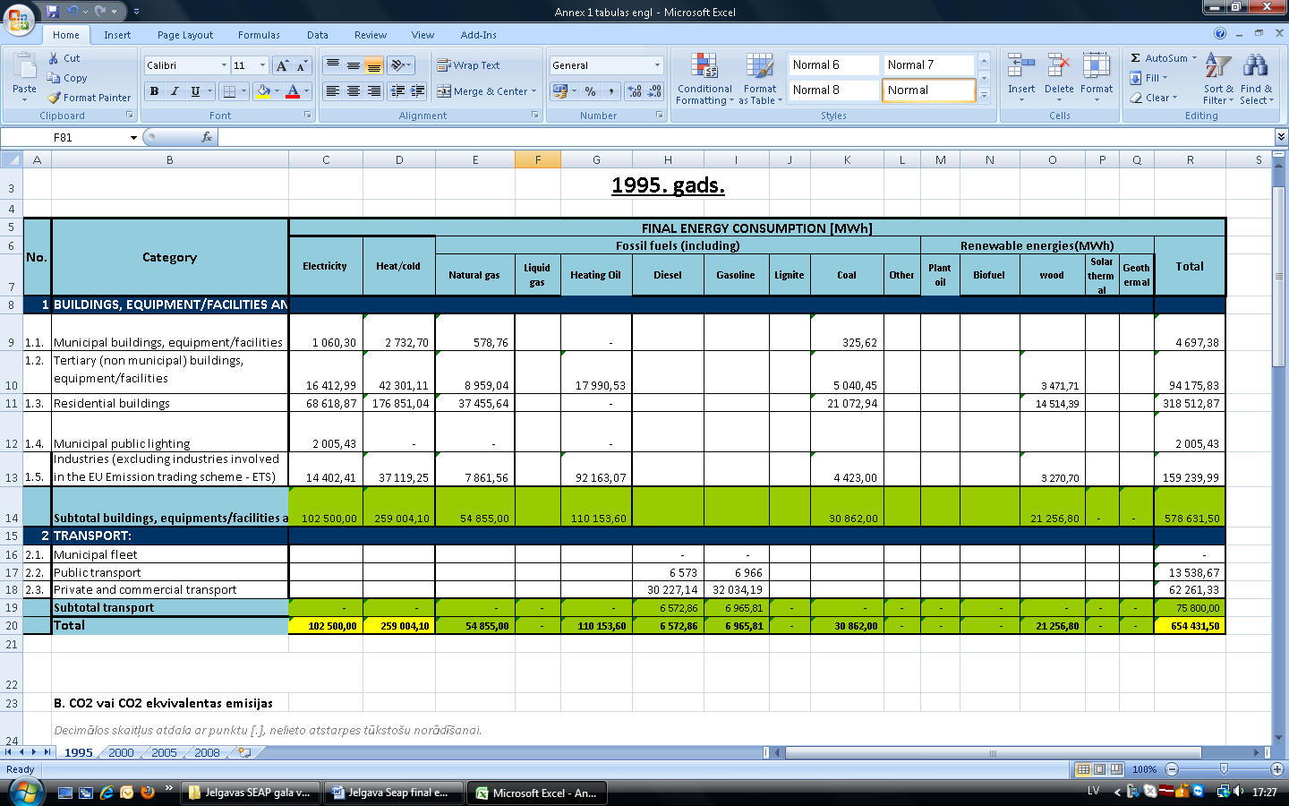

CO₂ emissions or emissions equal to CO₂, 1995

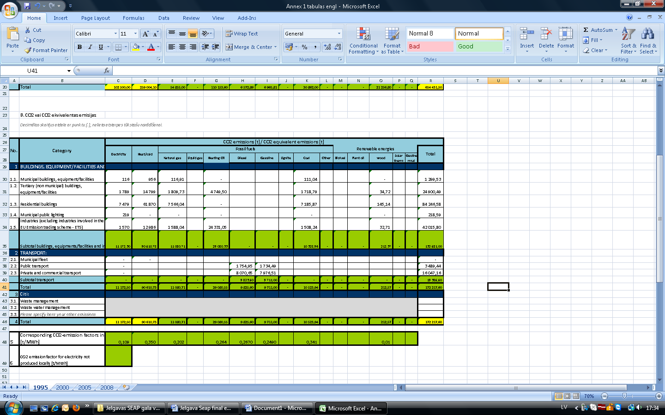

Locally produced electric power and the respective CO₂ emissions, 1995

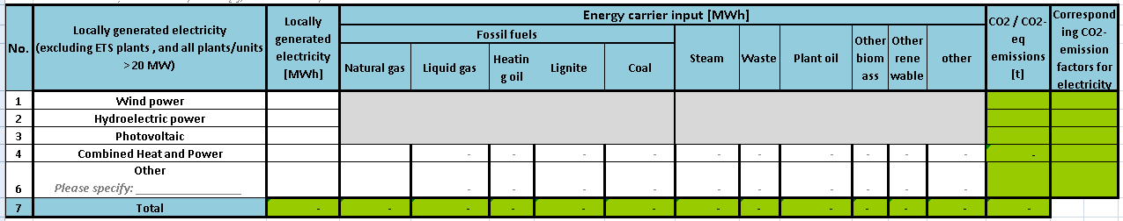

Local production of heat/cold (district heating/cooling, co-generation plants) and the respective CO₂ emissions, 1995

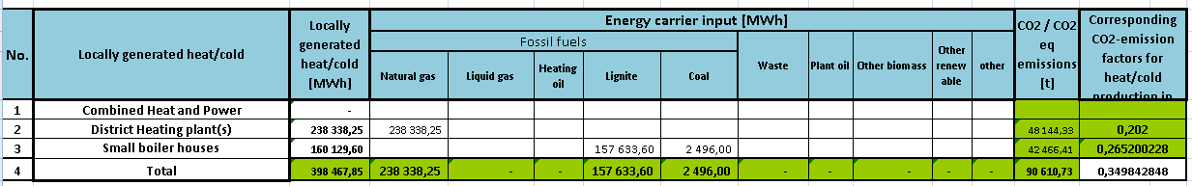

Final energy consumption, 2000
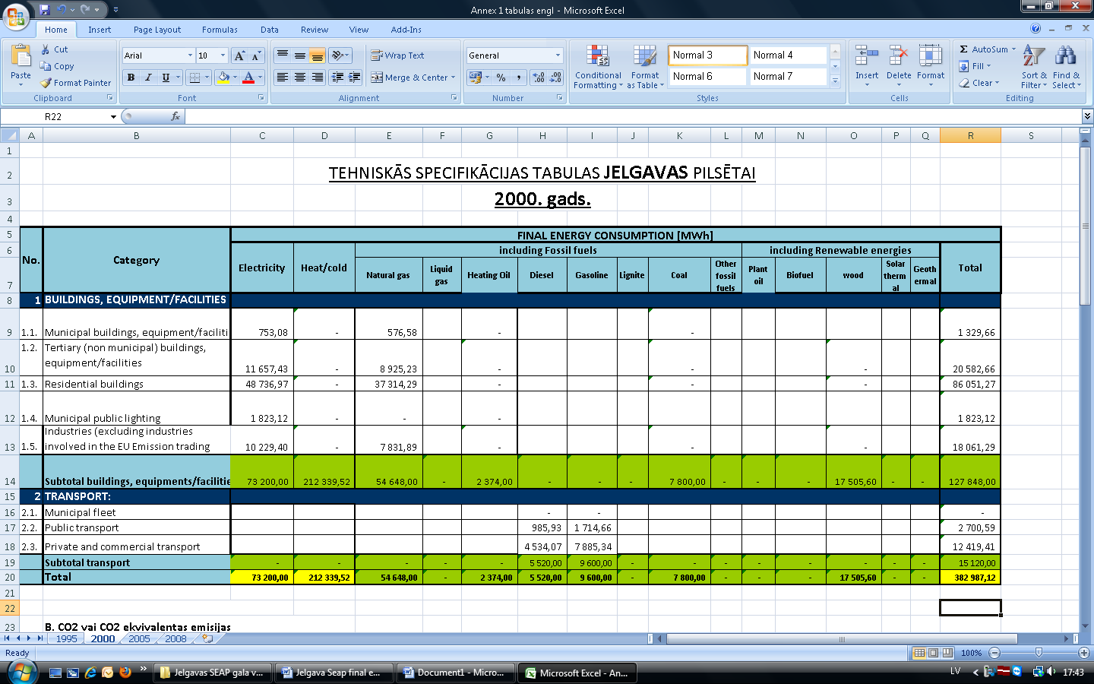

CO₂ emissions or emissions equal to CO₂, 2000

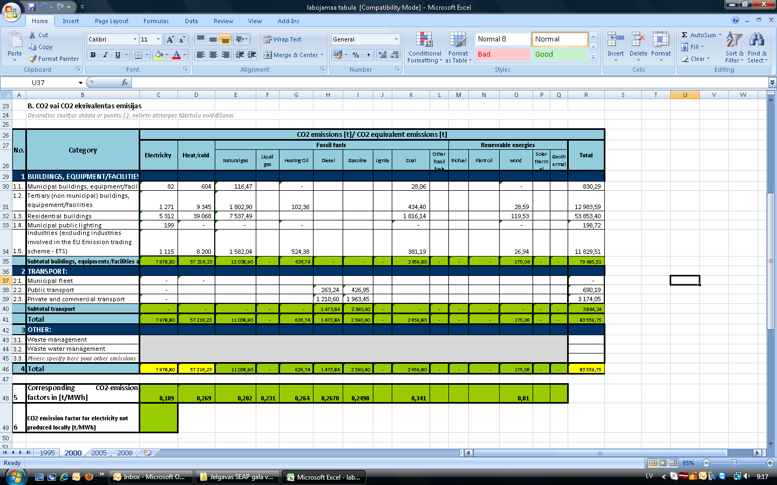

Locally produced electric power and the respective CO₂ emissions, 2000

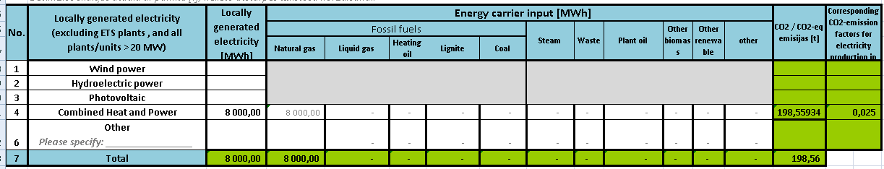

Local production of heat/cold (district heating/cooling, co-generation plants) and the respective CO₂ emissions, 2000

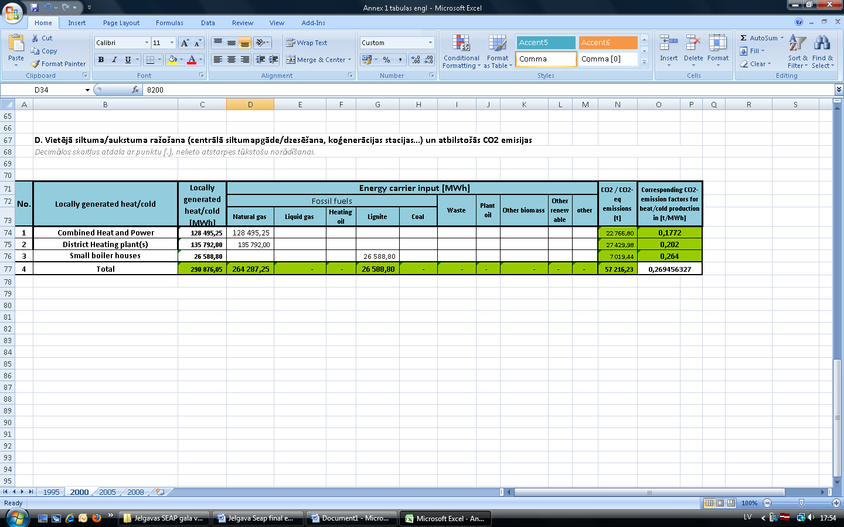

Final energy consumption, 2005 (baseline year)
Becoming a member of Covenant of Mayors the municipality of Jelgava has undertaken to reduce CO₂ emissions in its territory at least by 20 % in the time period till 2020. In order to meet this goal the situation in the municipality was recorded as for the year of 2005 9or the baseline year).

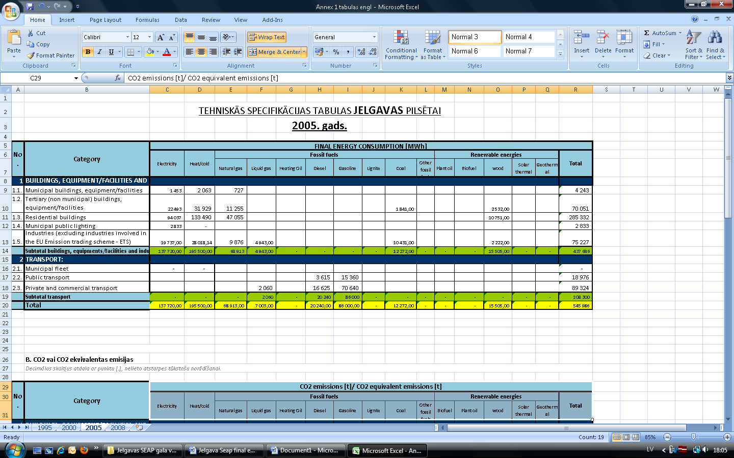

CO₂ emissions or emissions equal to CO₂, 2005 (baseline year)

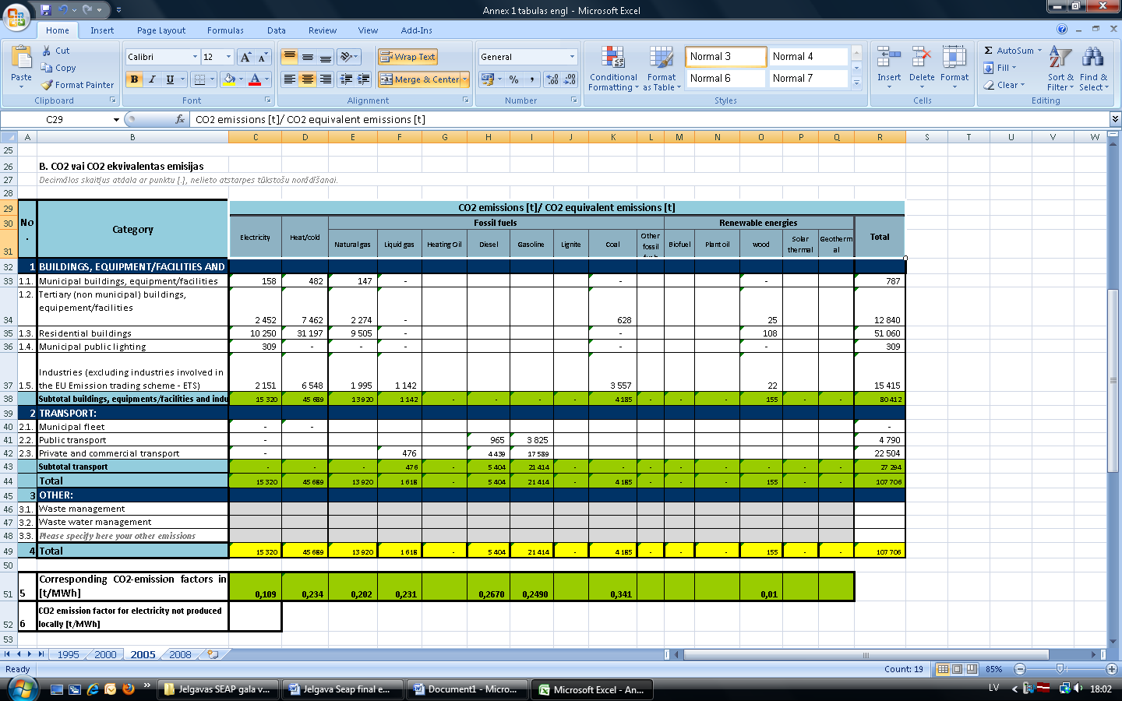

Locally produced electric power and the respective CO₂ emissions, 2005 (baseline year)

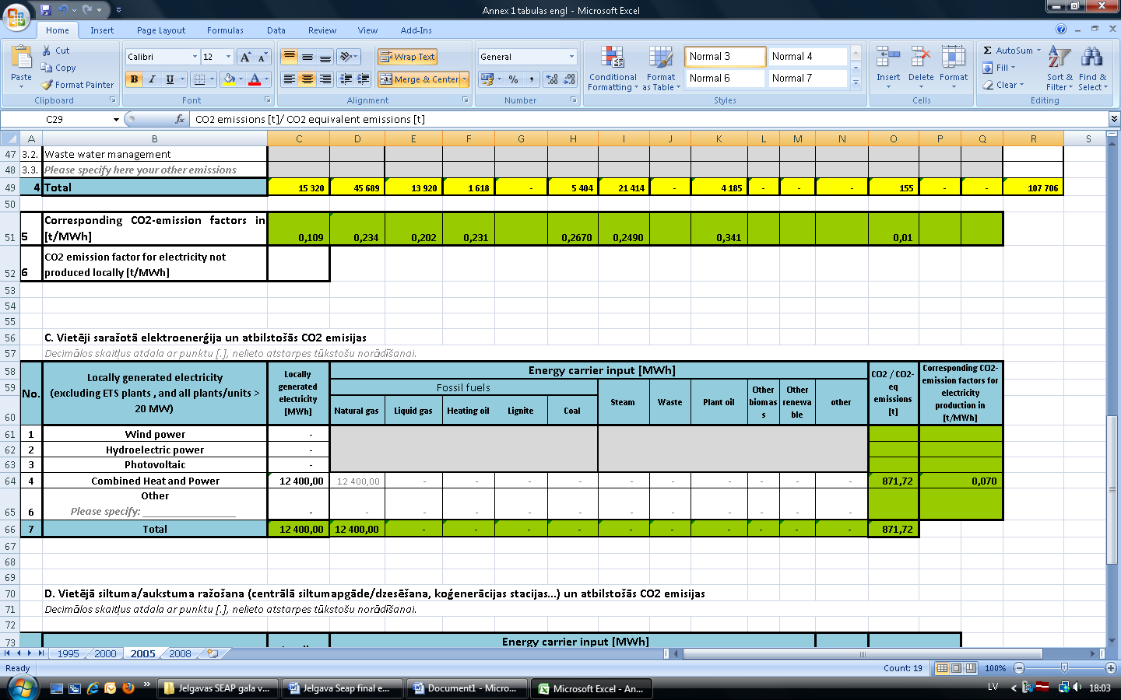

Local production of heat/cold (district heating/cooling, co-generation plants) and the respective CO₂ emissions, 2005 (baseline year)

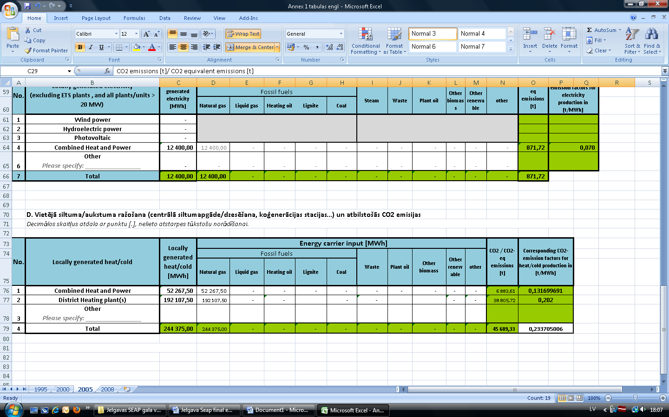

Final energy consumption, 2008
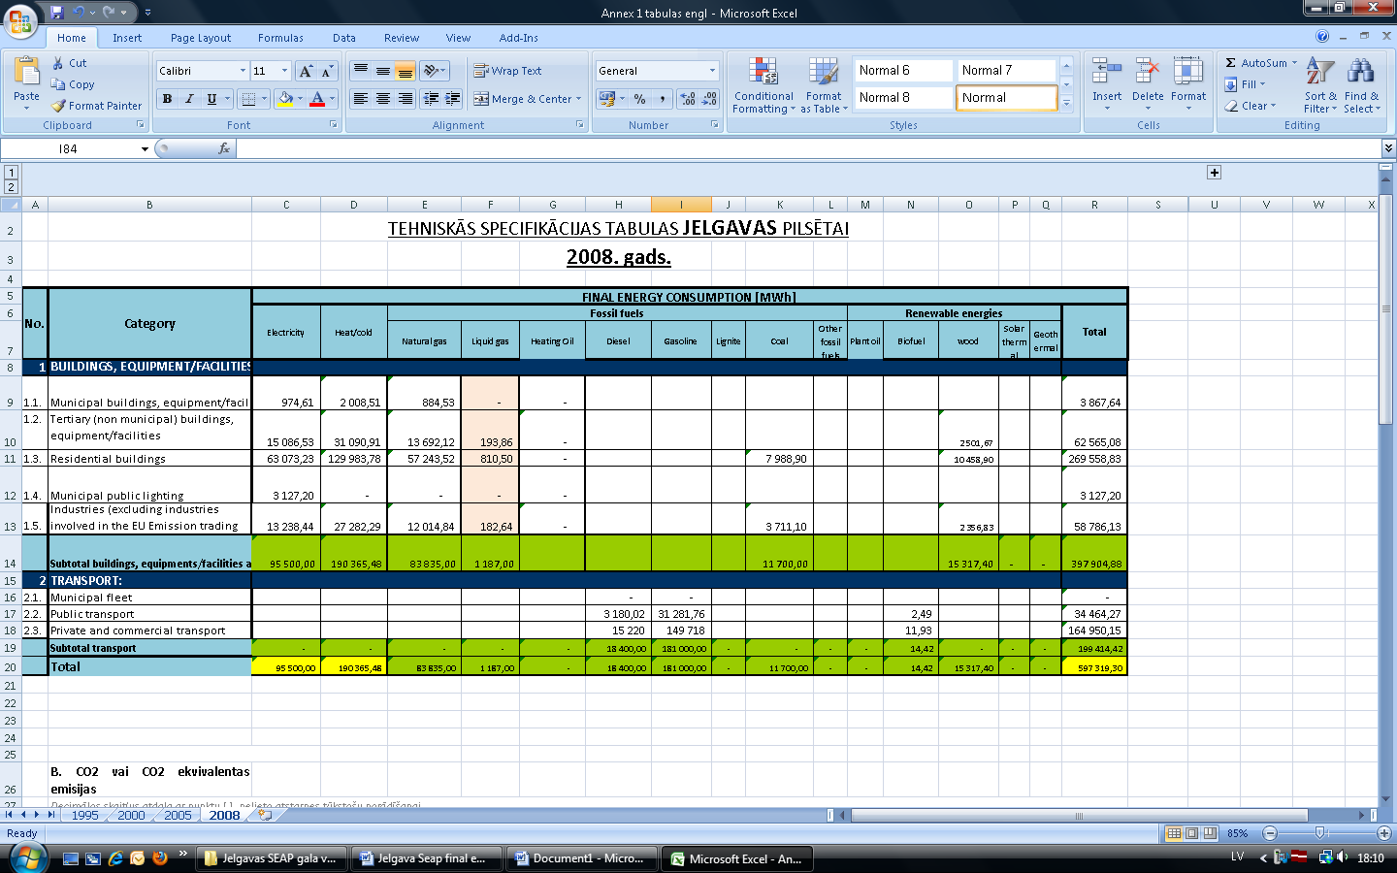

CO₂ emissions or emissions equal to CO₂, 2008

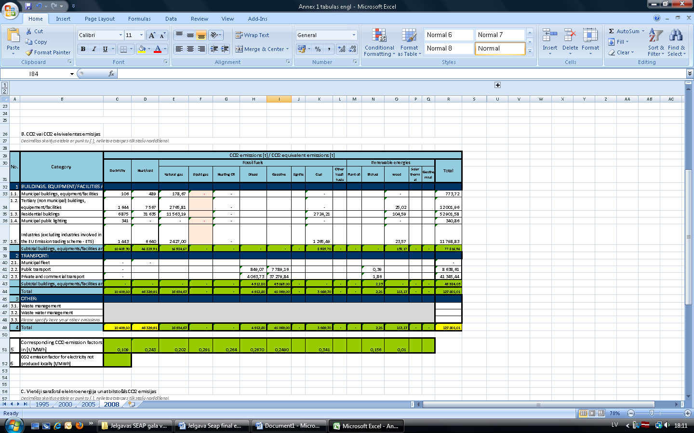

Locally produced electric power and the respective CO₂ emissions, 2008

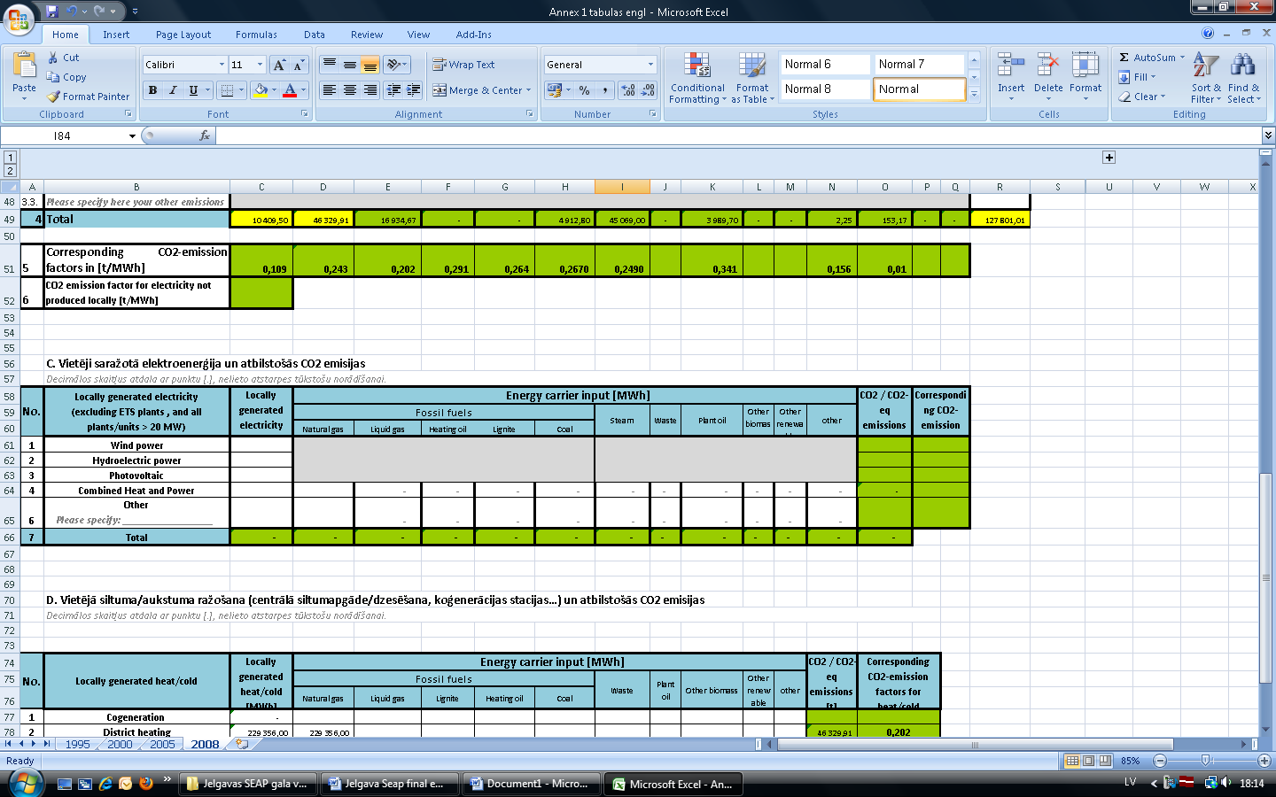

Local production of heat/cold (district heating/cooling, co-generation plants) and the respective CO₂ emissions, 2008

